**CAN THO UNIVERSITY SOFTWARE CENTER**

**MEKONG DELTA - APTECH**

**SEMESTER PROJECT – III**

**DOCTORS WEB FORUM**

**Instructor: Class: CP2096H01**

Ms. LINH ONG THI MY **Team: GROUP 05**

**Students:**

1. Student1291151 – THANH LE HOANG TRI

2. Student1153187 – THUAN DAO MINH TRUNG

3. Student1058405 – HOANG LE THIEN

**Can Tho, July 03 2022**

# TABLE OF CONTENTS

TABLE OF CONTENTS 1

TABLE OF FIGURE 3

TABLE OF TABLE 4

1 PROBLEM DEFINITION 1

2 CUSTOMER REQUIREMENT SPECIFICATION (CRS) 1

2.1 Client: Doctors web forum 1

2.2 Overview of processes involved in the system 1

2.2.1 Guest 1

2.2.2 Account user 2

2.2.3 Admin user 2

2.2.4 Home page 3

2.3 Expected Delivery Dates: 03/6/2022 4

2.4 List of Deliverables 4

2.5 Hardware and Software requirements 4

2.6 Scope of the Work (in brief) 4

3 ARCHITECTURE AND DESIGN OF THE PROJECT 1

3.1 ARCHITECTURE AND DESIGN OF THE PROJECT 1

3.2 CLASS DIAGRAM 2

3.3 USE CASE DIAGRAM 3

3.3.1 USE CASE GUESS 3

3.3.2 USE CASE CUSTOMER AND DOCTOR 4

3.3.3 USE CASE LOGIN 5

3.3.4 USE CASE SEARCH 6

3.4 ACTIVITY DIAGRAM 7

3.4.1 REGISTER: 7

3.4.2 LOGIN 8

3.4.3 DELETE ACCOUNT USER 9

3.4.4 CREAT COMMENT: 10

3.4.5 SEARCH 11

3.4.6 UPDATE COMMENT: 12

3.4.7 DELETE COMMENT 13

3.4.8 USER ONLINE 14

3.5 DATABASE DESIGN/STRUCTURE: 14

3.5.1 Achievement table 2

3.5.2 Customer table 2

3.5.3 Doctor And Admin table 3

3.5.4 Diploma table 4

3.5.5 Post Detail table 4

3.5.6 Professional table 5

3.5.7 Quanlification table 5

3.5.8 Topic table 5

4 TASK SHEET 1

5 REVIEW 1

5.1 IMPLEMENTATION CHECKLIST 1

5.2 SUBMISSION CHECKLIST 2

6 INSTALLATION GUIDE 1

6.1 REQUIREMENT 1

6.2 STARTUP 1

7 DEMO 2

# TABLE OF FIGURE

Figure 1 Architecture and Design of The Project 1

Figure 2 Class diagram 2

Figure 3: Use case guess 3

Figure 4 Use case Customer and Doctor 4

Figure 5 Use case login 5

Figure 6 Use case search 6

Figure 7 Activity diagram register 7

Figure 8 Activity diagram login 8

Figure 9 Activity diagram delete account user 9

Figure 10 Activity diagram create comment 10

Figure 11 Activity diagram search 11

Figure 12 Activity diagram update comment 12

Figure 13 Activity diagram delete comment 13

Figure 14 Activity diagram user login 14

Figure 15 Database design 1

Figure 16 User management 2

Figure 17 View post of user 2

Figure 18 Create user 3

Figure 19 Edit user 3

Figure 20 Delete user 4

Figure 21 Post management 4

Figure 22 Create Post 5

Figure 23 Delete Post 5

Figure 24 View and edit profile 6

Figure 25 Logout 6

Figure 26 Home page 7

Figure 27 End of home page 7

Figure 28 View post 8

Figure 29 Register User 8

Figure 30 Login 9

Figure 31 Customer profile 9

Figure 32 Edit profile customer 10

Figure 33 Doctor profile 10

Figure 34 Edit doctor profile 11

Figure 35 Doctor Achievement 11

Figure 36 Create Achievement 12

Figure 37 Edit Achievement 12

Figure 38 Delete Achievement 13

Figure 39 Doctor Qualification 13

Figure 40 Edit Qualification 14

Figure 41 Delete Qualification 14

Figure 42 Doctor Professional 15

Figure 43 Create Professional 15

Figure 44 Edit Professional 16

Figure 45 Delete Professional 16

Figure 46 Create new post 17

Figure 47 Comment on Post 17

Figure 48 Search 18

# TABLE OF TABLE

Table 1 Achievement table 2

Table 2 Customer table 3

Table 3 Doctor and Admin table 3

Table 4 Diploma table 4

Table 5 Post detail table 4

Table 6 Profesional table 5

Table 7 Quanlification table 5

Table 8 Topic table 5

Table 9 Task sheet 2

Table 10 Implementation checklist 1

Table 11 Submission checklist 2

Table 12 Accounts list 1

# PROBLEM DEFINITION

The need to learn knowledge, access scientific and technical information has become popular when the internet develops strongly today. Although learning and updating knowledge is quick and convenient, it is sometimes difficult to find the necessary information in a large amount of information, especially in the field of medicine, information and opinions. For researchers, doctors' experiences are exchanged together to better understand, as well as update new knowledge, new information is essential. The need for a forum wed doctor to create a place to exchange and exchange information is necessary

# CUSTOMER REQUIREMENT SPECIFICATION (CRS)

## Client: Doctors web forum

**Business/Project Objective:** Our client is a doctor who is one of the famous Cardiac specialists in the country. As he is one of the famous specialists in the country, he generally used to visit some places for operating some patients with some critical cardiac conditions. Also he used to get invitations from various colleges in the country for attending and giving the seminars, also he runs a college, which is one of the famous Medical colleges in the country.

Actually, he wants an online application such as a discussion forum for the doctors in the world, so that if any one is having any queries (for the junior doctors, etc.) or to discuss some new cases in different fields. He wants this application to be developed as this can bridge the gap between the various doctors available in the world and can know each other through this portal. Also, in case of any emergencies or for some special cases one can go through the application and search for the various doctors based on the specialization and the location which ever is suitable so that so many people s lives can be saved.

## Overview of processes involved in the system

### Guest

**Register account**

* in: contact details, personal, role user (Doctor/Normal user). If doctor, info of professional, qualification, experience, and as well the achievement details, viewable option (public/private)
* out: direct to homepage if success, fail message popup otherwise

**Search**

* in: Type search (basic/advanced) Search text Advanced search: search by
* out: Posts have title, tags include search text. User if search text is surname or full name

**Create Post (Doctor/Normal user)**

* in: Post details, title, tags, content
* out: Message success or fail, Created post

**Delete Post (Doctor/Normal user)**

* in: Own post
* out: Message success or fail

**Comment (Doctor/Normal user)**

* in: Post, comment content
* out: Added comment

**Delete comment (Doctor/Normal user)**

* in: Post, comment
* out: Deleted comment

### Account user

**Login**

* in: username, password
* out: direct to homepage if success, fail message popp otherwise

**Change user information**

* in: new contact details, personal, professional, qualification, experience, and as well the achievement details if doctor sets viewable option (public/private)
* out: Message success or fail

**Search**

* in: Type search (basic/advanced) Search text Advanced search: search by
* out: Posts have titles, tags include search text. User if search text is surname or full name

**Create Post (Doctor/Normal user)**

* in: Post details, title, tags, content
* out: Message success or fail, Created post

**Delete Post (Doctor/Normal user)**

* in: Own post
* out: Message success or fail

**Comment (Doctor/Normal user)**

* in: Post, comment content
* out: Added comment

**Delete comment (Doctor/Normal user)**

* in: Post, comment
* out: Deleted comment

### Admin user

**Change user information**

* in: new contact details, personal, professional, qualification, experience, and as well the achievement details if doctor..., viewable option (public/private)
* out: Message success or fail

**Search**

* in: Type search (basic/advanced) Search text, advanced search: search by …
* out: Posts have titles, tags include search text. User if search text is surname or full name

**Create Post (Doctor/Normal user)**

* in: Post details, title, tags, content
* out: Message success or fail, Created post

**Delete Post (Doctor/Normal user)**

* in: Own post
* out: Message success or fail

**Comment (Doctor/Normal user)**

* in: Post, comment content
* out: Added comment

**Delete comment (Doctor/Normal user)**

* in: Post, comment
* out: Deleted comment

**Delete User (Admin)**

* in: Account
* out: Message success or fail

**Delete Post (Admin)**

* in: Post
* out: Message success or fail

**Delete Comment (Admin)**

* in: Comment
* out: Message success or fail

### Home page

**Homepage of forum)**

* in: number of registered users, number of logged in users
* out: show number of registered users, number of logged in users.

**Notice: logo, background (cross)**

**User role:**

* Admin: Account of Client
* Doctor: Doctor account, include info of professional, qualification, experience, and as well the + achievement details when registering.
* Normal User

## Expected Delivery Dates: 03/6/2022

## List of Deliverables

* Working Application
* Source Code
* Database
* Compiled Code
* eProject Report
* Document:
* Problem Definition
* Customer Requirement Specification
* Architecture and Design of the Project
* Class Diagram
* Use-case Diagrams
* Activity DiagramsDatabase Design/StructureTask Sheet
* Checklist of Validations
* Submission Checklist
* Supporting Document
* User Guide

## Hardware and Software requirements

|  |  |  |
| --- | --- | --- |
|  | **Server** | **Client** |
| **Hardware** | * CPU: intel core i5 * RAM: 4GB RAM or better * HDD: 500GB Hard Disk space or higher | * CPU: intel core i3 * RAM: 2GB or higher * HDD 128 GB or higher * Operating system: Window 8 or better |
| **Software** | * Window server 2012 * Internet Information * Service (IIS) or other server. * .NET Framework 4.6 * SQL Server 2019 | * Window 7/ 8/ 8.1/ 10 (or higher) * Browsers: IE..., Chrome… |

## Scope of the Work (in brief)

* Build a system that meets the following requirements:
* Build Doctors web forum based on client-server model.
* The system will be maintained and repaired if any problems occur with the system.
* The system has the functions as stated:

**Guest**

* View information about comments, posts, personal information of registered members (members on public profile).
* Register
* Login
* Search information about comments, posts, personal information of registered members (members on public profile).

**Authenticated Customer**

* Make a question.
* Write a comment
* Post a research paper, an event.
* Public profile.
* View information about comments, posts, personal information of registered members (members on public profile).
* Search information by Date.
* Search information about comments, posts, personal information of registered members (members on public profile).
* Update profile.
* Change password.

**Authenticated Doctor**

* Make a question.
* Write a comment
* Post a research paper, an event.
* Public profile.
* View information about comments, posts, personal information of registered members (members on public profile).
* Search information by Date.
* Search information about comments, posts, personal information of registered members (members on public profile).
* Update profile.
* Change password.

**Admin**

* Make a question.
* Write a comment
* Post a research paper, an event.
* Public profile.
* View information about comments, posts, personal information of registered members (members on public profile).
* Search information by Date.
* Search information about comments, posts, personal information of registered members (members on public profile).
* Update profile.
* Change password.
* Delete account customer and doctor.
* Create account customer and doctor.

**On the home page**

* Show the nunber of users registered(count) and the number of users logged (count) in are to be displayed at the top corner of the page.

# ARCHITECTURE AND DESIGN OF THE PROJECT

## ARCHITECTURE AND DESIGN OF THE PROJECT

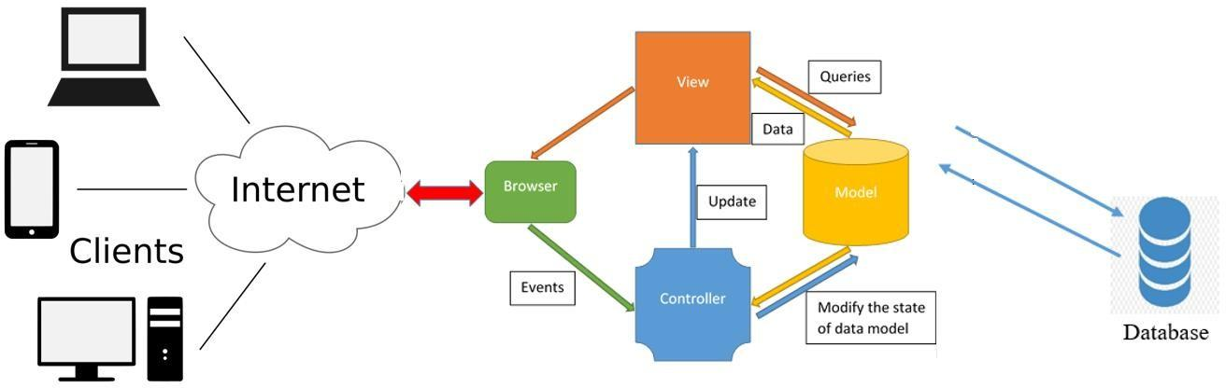

Figure Architecture and Design of The Project

## CLASS DIAGRAM

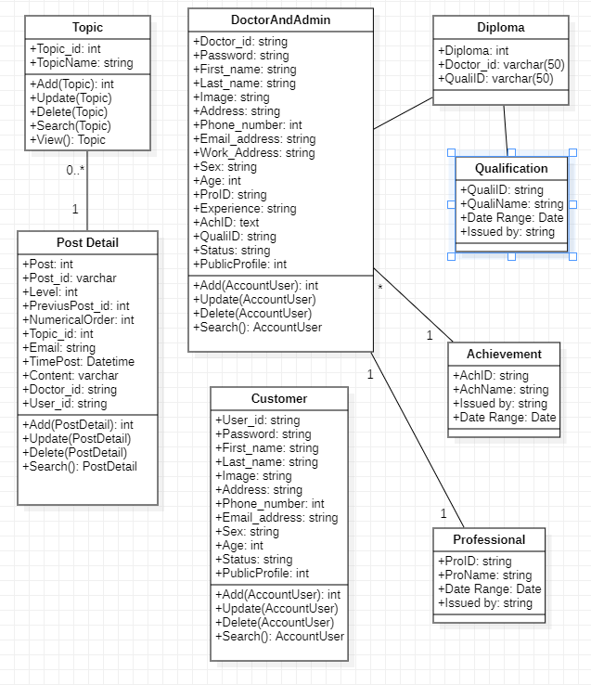

Figure Class diagram

## USE CASE DIAGRAM

### USE CASE GUESS

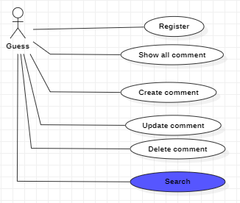

Figure : Use case guess

### USE CASE CUSTOMER AND DOCTOR

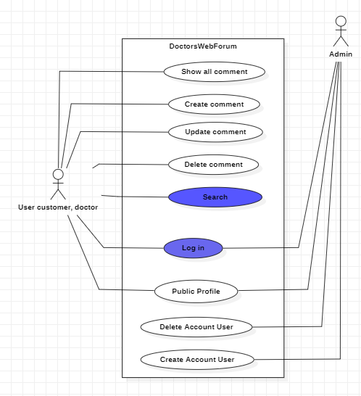

Figure Use case Customer and Doctor

### USE CASE LOGIN

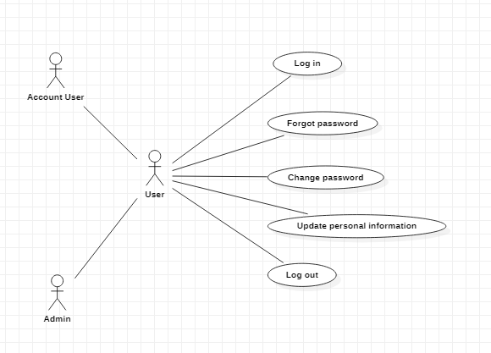

Figure Use case login

### USE CASE SEARCH

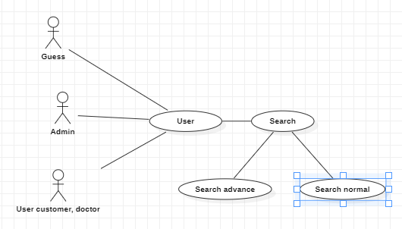

Figure Use case search

## ACTIVITY DIAGRAM

### REGISTER:

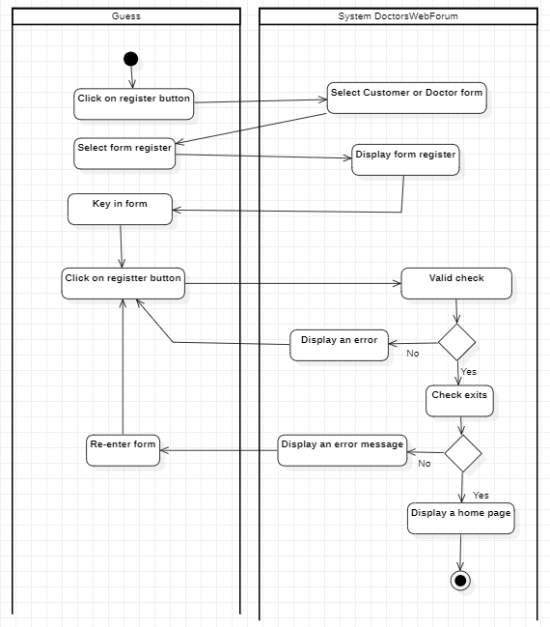

Figure Activity diagram register

### LOGIN

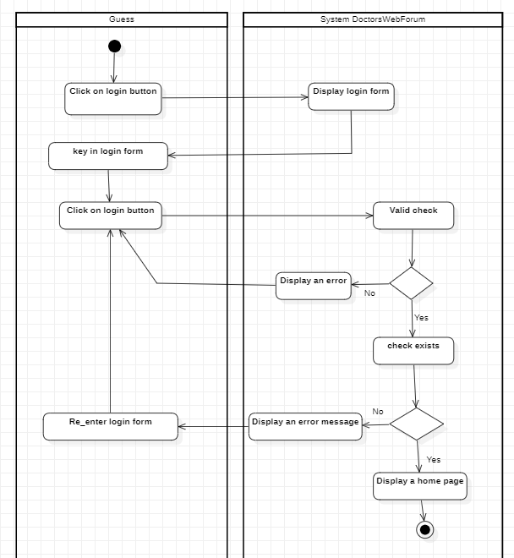

Figure Activity diagram login

### DELETE ACCOUNT USER

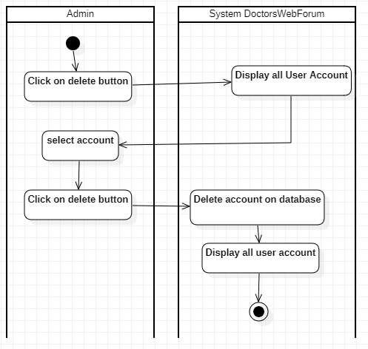

Figure Activity diagram delete account user

### CREAT COMMENT:

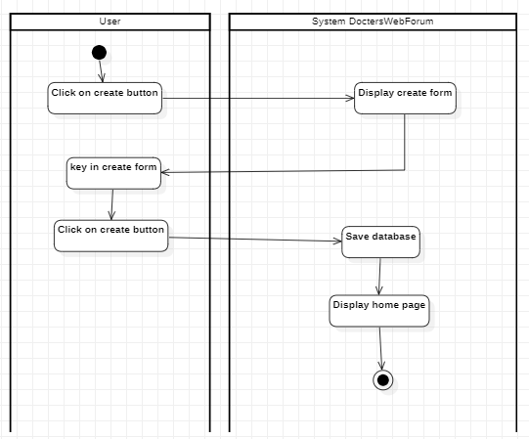

Figure Activity diagram create comment

### SEARCH

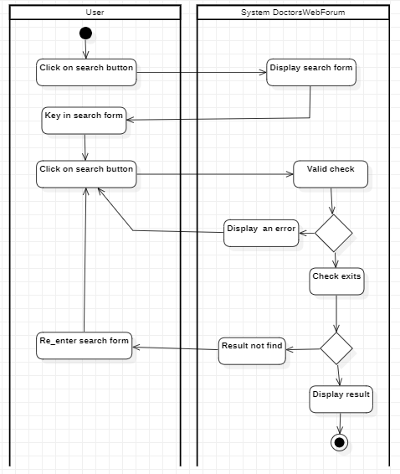

Figure Activity diagram search

### UPDATE COMMENT:

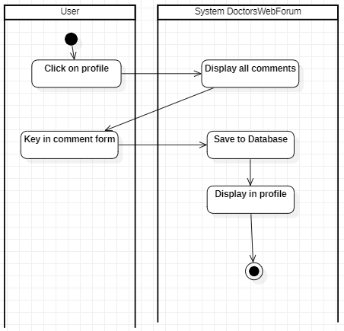

Figure Activity diagram update comment

### DELETE COMMENT

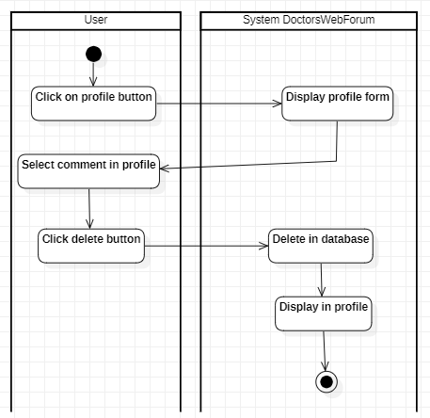

Figure Activity diagram delete comment

### USER ONLINE

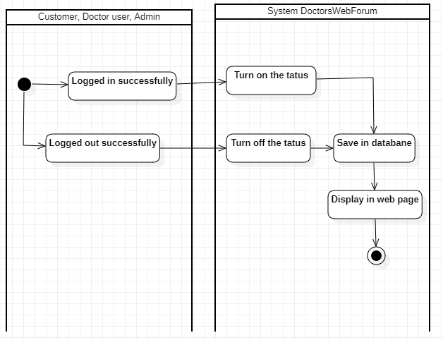

Figure Activity diagram user login

## DATABASE DESIGN/STRUCTURE:

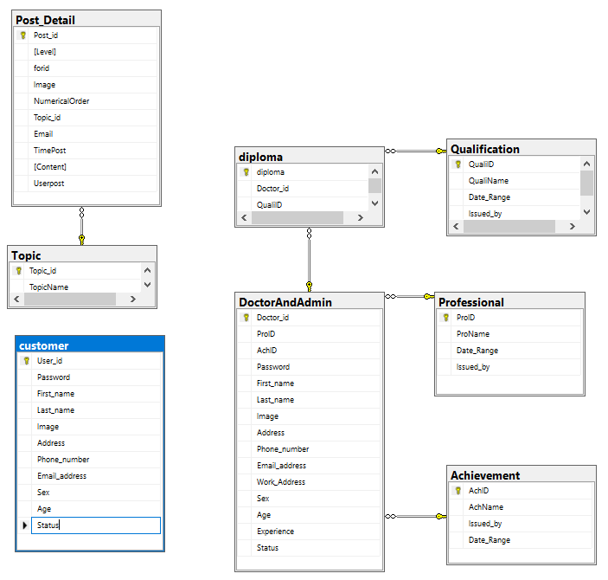

Figure Database design

### Achievement table

|  |  |  |  |  |
| --- | --- | --- | --- | --- |
| **Achievement** | | | | |
| **Field Name** | **Data Type** | **Null** | **Key** | **Description** |
| AchID | varchar(50) | No | PK |  |
| AchName | varchar(50) | Yes |  |  |
| Issued_by | varchar(50) | Yes |  |  |
| Date Range | date | Yes |  |  |

Table Achievement table

### Customer table

|  |  |  |  |  |
| --- | --- | --- | --- | --- |
| **Customer** | | | | |
| **Field Name** | **Data Type** | **Null** | **Key** | **Description** |
| User_id | varchar(50) | No | PK |  |
| Password | varchar(50) | Yes |  |  |
| Fist_name | varchar(50) | Yes |  |  |
| Last_name | varchar(50) | Yes |  |  |
| Image | varchar(50) | Yes |  |  |
| Address | varchar(50) | Yes |  |  |
| Phone_number | varchar(50) | Yes |  |  |
| Email_address | varchar(50) | Yes |  |  |
| Sex | varchar(50) | Yes |  |  |

|  |  |  |  |  |
| --- | --- | --- | --- | --- |
| Age | Int | Yes |  |  |
| Status | varchar(50) | Yes |  |  |

Table Customer table

### Doctor And Admin table

|  |  |  |  |  |
| --- | --- | --- | --- | --- |
| **Doctor and Admin** | | | | |
| **Field Name** | **Data Type** | **Null** | **Key** | **Description** |
| Doctor_id | varchar(50) | No | PK |  |
| ProID | varchar(50) | Yes |  |  |
| Password | varchar(50) | Yes |  |  |
| AchID | varchar(50) | Yes |  |  |
| Fist_name | varchar(50) | Yes |  |  |
| Last_name | varchar(50) | Yes |  |  |
| Image | varchar(50) | Yes |  |  |
| Address | varchar(50) | Yes |  |  |
| Phone_number | varchar(50) | Yes |  |  |
| Email_address | varchar(50) | Yes |  |  |
| Work_Address | varchar(50) | Yes |  |  |
| Sex | varchar(50) | Yes |  |  |
| Age | Int | Yes |  |  |
| Experience | varchar(50) | Yes |  |  |
| Status | varchar(50) | Yes |  |  |

Table Doctor and Admin table

### Diploma table

|  |  |  |  |  |
| --- | --- | --- | --- | --- |
| **Diploma** | | | | |
| **Field Name** | **Data Type** | **Null** | **Key** | **Description** |
| Diploma | Int | No | PK |  |
| Doctor_id | varchar(50) | Yes |  |  |
| QualiID | varchar(50) | Yes |  |  |

Table Diploma table

### Post Detail table

|  |  |  |  |  |
| --- | --- | --- | --- | --- |
| **Post Detail** | | | | |
| **Field Name** | **Data Type** | **Null** | **Key** | **Description** |
| Post_id | varchar(50) | No | PK |  |
| [Level] | int | Yes |  |  |
| forid | varchar(50) | Yes |  |  |
| Image | varchar(50) | Yes |  |  |
| NumericalOrder | int | Yes |  |  |
| Topic_id | int | Yes |  |  |
| Email | varchar(50) | Yes |  |  |
| TimePost | datetime | Yes |  |  |
| [Content] | varchar(250) | Yes |  |  |
| Useport | varchar(250) | Yes |  |  |

Table Post detail table

### Professional table

|  |  |  |  |  |
| --- | --- | --- | --- | --- |
| **Professional** | | | | |
| **Field Name** | **Data Type** | **Null** | **Key** | **Description** |
| ProID | varchar(50) | No | PK |  |
| ProName | varchar(50) | Yes |  |  |
| Date_Range | date | Yes |  |  |
| Issued_by | varchar(50) | Yes |  |  |

Table Profesional table

### Quanlification table

|  |  |  |  |  |
| --- | --- | --- | --- | --- |
| **Quanlification** | | | | |
| **Field Name** | **Data Type** | **Null** | **Key** | **Description** |
| QualiID | varchar(50) | No | PK |  |
| QuanliName | varchar(50) | Yes |  |  |
| Date_Range | date | Yes |  |  |
| Issued_by | varchar(50) | Yes |  |  |

Table Quanlification table

### Topic table

|  |  |  |  |  |
| --- | --- | --- | --- | --- |
| **Topic** | | | | |
| **Field Name** | **Data Type** | **Null** | **Key** | **Description** |
| Topic_id | int | No | PK |  |
| TopicName | varchar(50) | Yes |  |  |

Table Topic table

# TASK SHEET

|  |  |  |  |  |  |  |  |
| --- | --- | --- | --- | --- | --- | --- | --- |
| **Project Ref. No.:** | | **Project Title:** | **Activity Plan Prepared By:** | **Date of Preparation of Activity Plan:** | | | |
| **Sr.No.** | **Task** | **Actual Start Date** | **Actual Day** | **Team Mate Names** | **Status** |
| 1 | Form No.1 | Problem Definition | Thanh Le Hoang Tri | Jun - 03 - 2022 | 2 | Thuan Dao Minh Trung | Done |
| 2 | Form No.2 | CRS | Thanh Le Hoang Tri | Jun - 04 - 2022 | 2 | Hoang Le Thien | Done |
| 3 | Form No.3 | Architecture and Design | Thanh Le Hoang Tri | Jun - 13 - 2022 | 3 | All member | Done |
| 4 | Form No.4 | Database Design/  Structure | Thanh Le Hoang Tri | Jun - 16 - 2022 | 3 | All member | Done |
| 5 | Form No.5 | Task Sheet | Thanh Le Hoang Tri | Jun - 06 - 2022 | 1 | Thanh Le Hoang Tri | Done |
| 6 |  | Design template | Thanh Le Hoang Tri | Jun - 04 - 2022 | 6 | Thuan Dao Minh Trung | Done |
| 7 |  | Login(Admin) | Thanh Le Hoang Tri | Jun -05 - 2022 | 2 | Hoang Le Thien | Done |
| 8 |  | Admin user: Show all comment in user | Thanh Le Hoang Tri | Jun - 07 - 2022 | 3 | Hoang Le Thien | Done |
| 9 |  | Admin user: Create  account (customer and doctor) | Thanh Le Hoang Tri | Jun - 07 - 2022 | 3 | Thanh Le Hoang Tri | Done |
| 10 |  | Admin user: Update account (customer and doctor) | Thanh Le Hoang Tri | Jun - 10 - 2022 | 3 | Thanh Le Hoang Tri | Done |
| 11 |  | Admin user: Delete account (customer and doctor) | Thanh Le Hoang Tri | Jun - 13 - 2022 | 3 | Thanh Le Hoang Tri | Done |
| 12 |  | Admin user: Search | Thanh Le Hoang Tri | Jun - 16 - 2022 | 3 | Thanh Le Hoang Tri | Done |
| 13 |  | Show all comment  (Client) | Thanh Le Hoang Tri | Jun - 10 - 2021 | 3 | Thuan Dao Minh Trung | Done |
| 14 |  | Public profile | Thanh Le Hoang Tri | Jun - 13 - 2022 | 2 | Hoang Le Thien | Done |
| 15 |  | Update comment | Thanh Le Hoang Tri | Jun - 15 - 2022 | 2 | Hoang Le Thien | Done |
| 16 |  | Delete comment | Thanh Le Hoang Tri | Jun - 17 - 2022 | 2 | Hoang Le Thien | Done |
| 17 |  | Search | Thanh Le Hoang Tri | Jun - 11 - 2021 | 3 | Thuan Dao Minh Trung | Done |
| 18 |  | Show the number of members | Thanh Le Hoang Tri | Jun - 14 - 2021 | 1 | Thuan Dao Minh Trung | Done |
| 19 |  | Create comment  (client) | Thanh Le Hoang Tri | Jun - 15 - 2021 | 2 | Thuan Dao Minh Trung | Done |
| 20 |  | Create account user  (client) | Thanh Le Hoang Tri | Jun - 17 - 2021 | 2 | Thuan Dao Minh Trung | Done |
| 21 |  | User online | Thanh Le Hoang Tri | Jun - 19 - 2021 | 3 | Thuan Dao Minh Trung | Done |
| 22 | Form No.6 | Checklist of Validations | Thanh Le Hoang Tri | Jun - 25 - 2022 | 1 | All member | Done |
| 23 | Form No.7 | Submission Checklist | Thanh Le Hoang Tri | July - 02 - 2022 | 1 | All member | Done |

Table Task sheet

# REVIEW

## IMPLEMENTATION CHECKLIST

|  |  |
| --- | --- |
| **Option** | **Validated** |
| Do all numeric variables have a default value of zero? | Yes |
| Does the administrator have all the rights to create and delete the records? | Yes |
| Are all the records properly fed into the appropriate database? | Yes |
| Have all the modules been properly integrated and are completely functional? | Yes |
| Have all the design and coding standards been followed and implemented? | Yes |
| Is the design consistent all over? | Yes |
| Is the navigation sequence correct through all the screens in the application? | Yes |
| Is exception handling mechanism implemented in all the screens? | Yes |
| Are all the program codes working? | Yes |

Table Implementation checklist

## SUBMISSION CHECKLIST

|  |  |  |  |  |  |
| --- | --- | --- | --- | --- | --- |
| **Sr. No.** | **Particulars** | **Yes** | **No** | **NA** | **Comments** |
| 1. | Have all the modules been properly integrated and are they completely functional? | Yes |  |  |  |
| 2. | Does each unit meet its objective and purpose?  Are all the validations happening as specified in Process Design? | Yes |  |  |  |
| 3. | Have all Design and Coding standards been followed and implemented? | Yes |  |  |  |
| 4. | Is the GUI design consistent all over? | Yes |  |  |  |
| 5. | Are the codes working as per the specification? | Yes |  |  | All the modules are properly tested. |
| 6. | Does the application’s functionality resolve the client problem, and satisfy his needs completely? | Yes |  |  |  |
| 7. | Have the hardware and software been correctly chosen? | Yes |  |  |  |
| 8. | Additional features and utilities that give value addition to the entire project. | Yes |  |  |  |

Table Submission checklist

# INSTALLATION GUIDE

## REQUIREMENT

* Microsoft SQL Server 2019
* .NET Framework 4.7.2
* ISS Server

## STARTUP

1. Run SQL Database in file Database.sql
2. Deploy and run web app on ISS Server
3. User below accounts to access forum

|  |  |  |  |
| --- | --- | --- | --- |
| **No.** | **User ID** | **Password** | **Description** |
| 1 | admin | 123456 | Admin of Forum |
| 2 | customer1 | 123456 | Customer |
| 3 | customer2 | 123456 | Customer |
| 4 | doctor1 | 123456 | Doctor |
| 5 | doctor2 | 123456 | Doctor |
| 6 | doctor3 | 123456 | Doctor |
| 7 | hoang | 123456 | Customer |
| 8 | thanh | 123456 | Customer |
| 9 | thuan | 123456 | Customer |

Table Accounts list

# DEMO

1. Admin Page
   1. User management

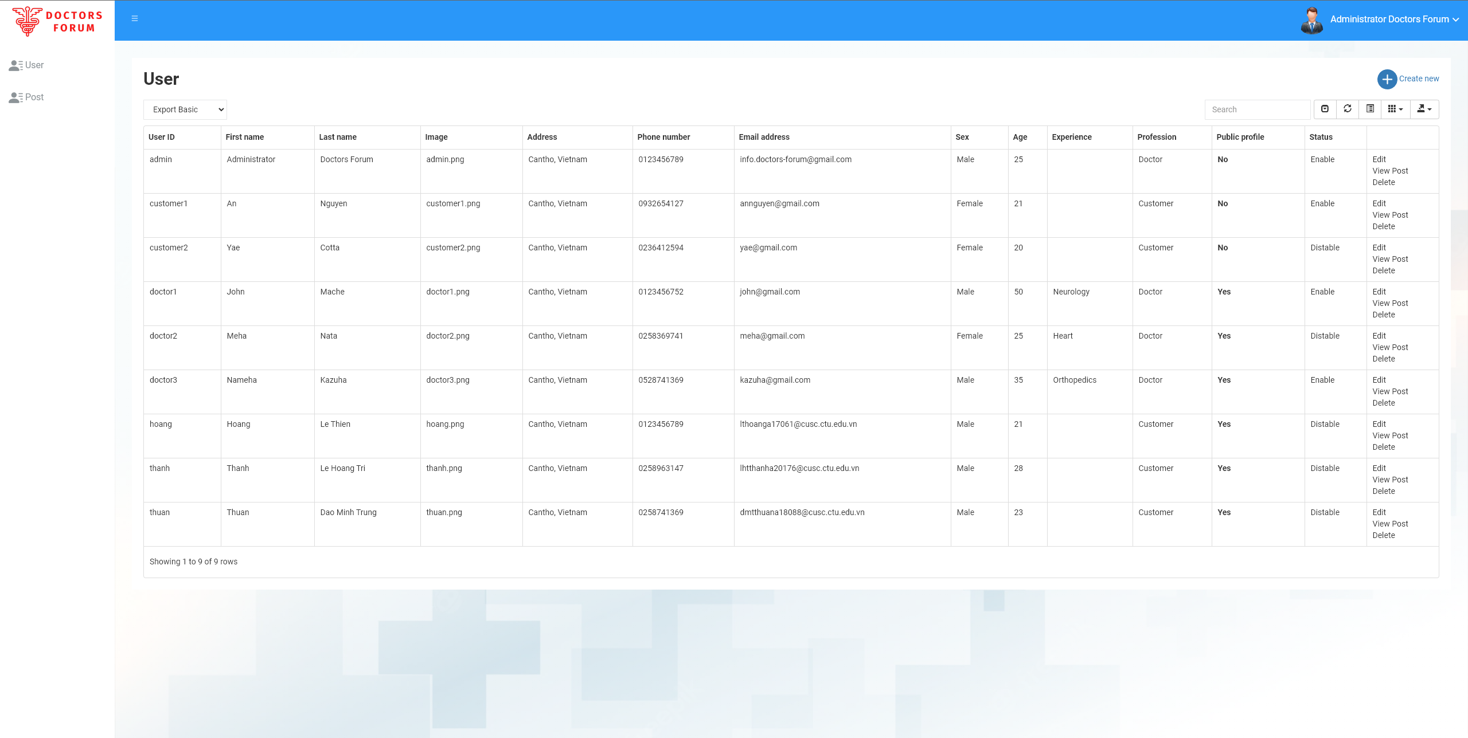

Figure User management

* 1. View post of user

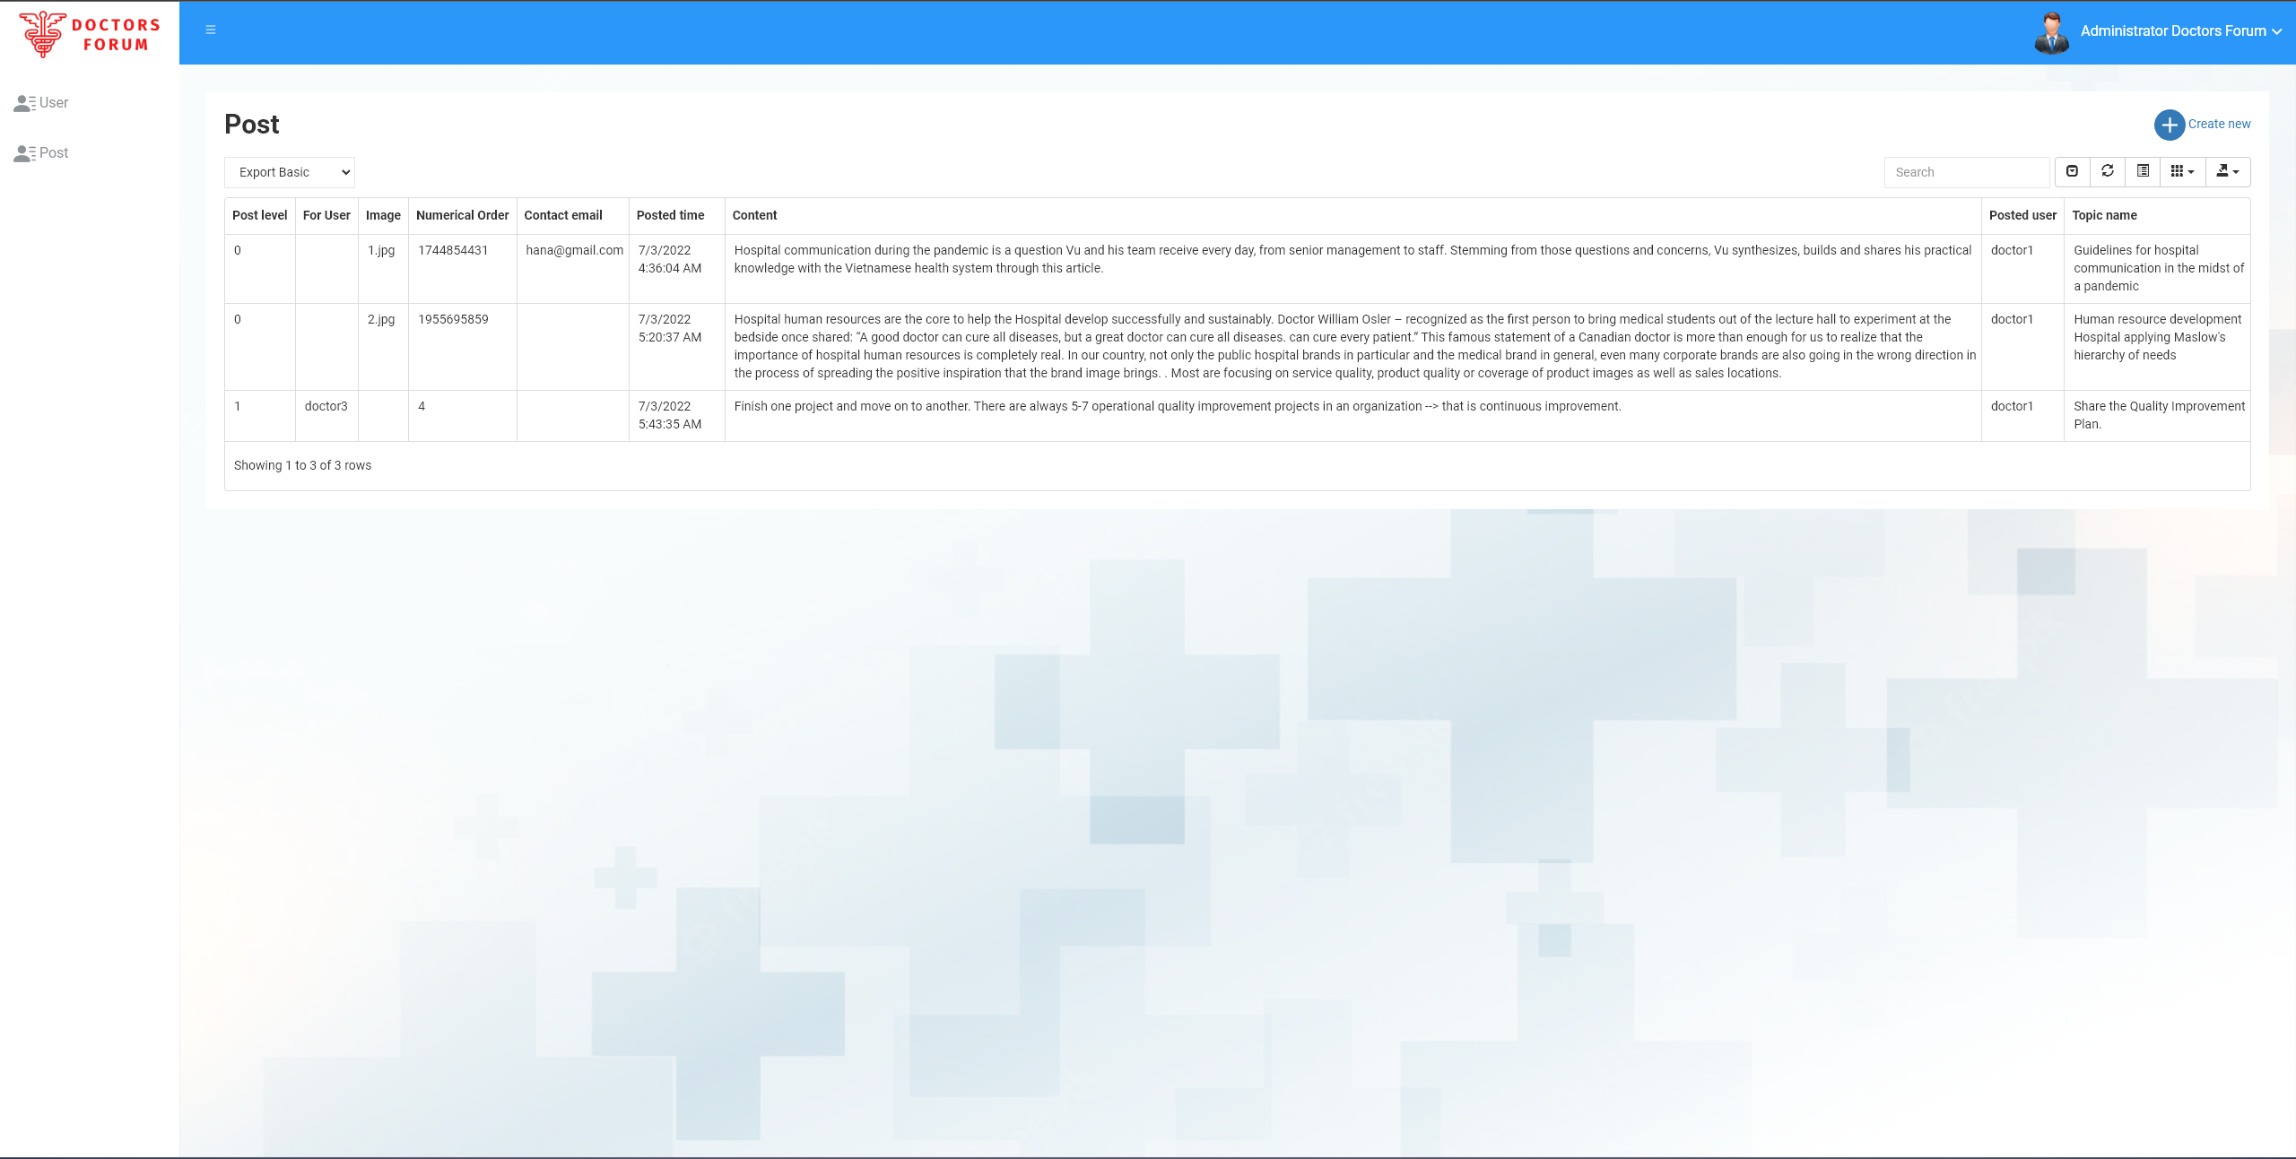

Figure View post of user

* 1. Create user

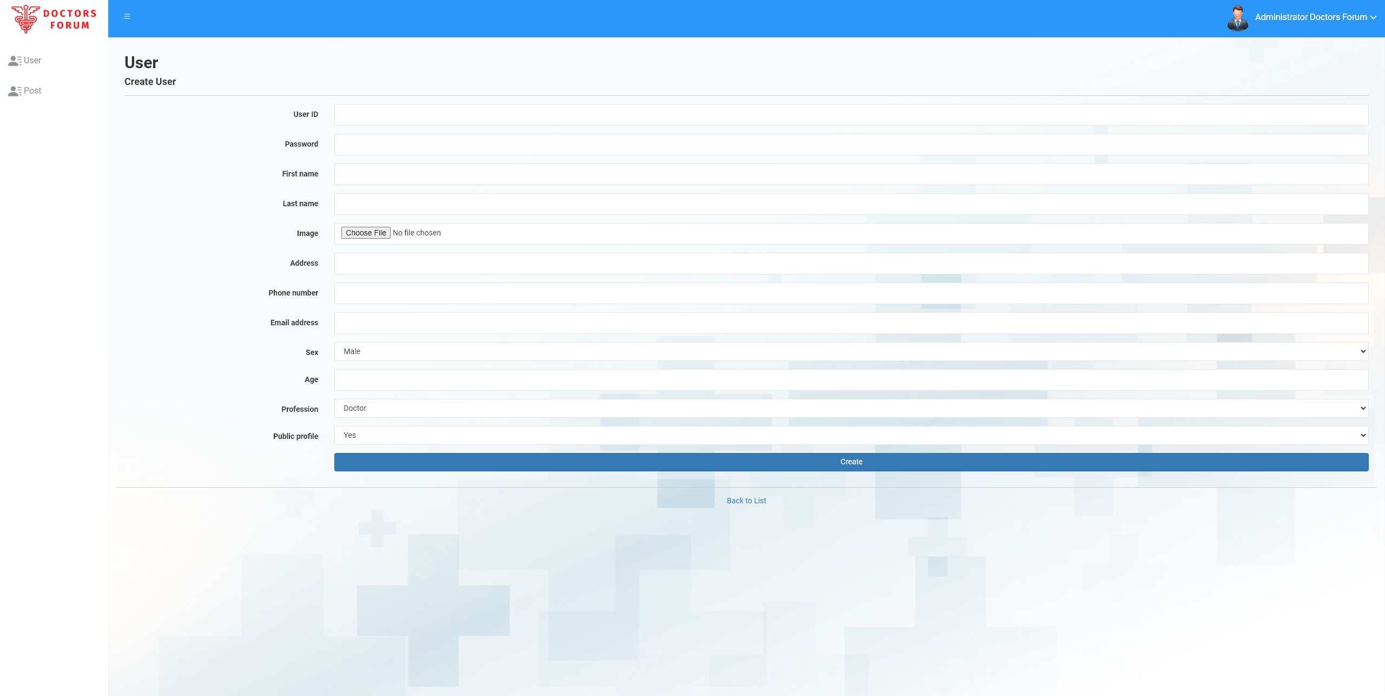

Figure Create user

* 1. Edit user

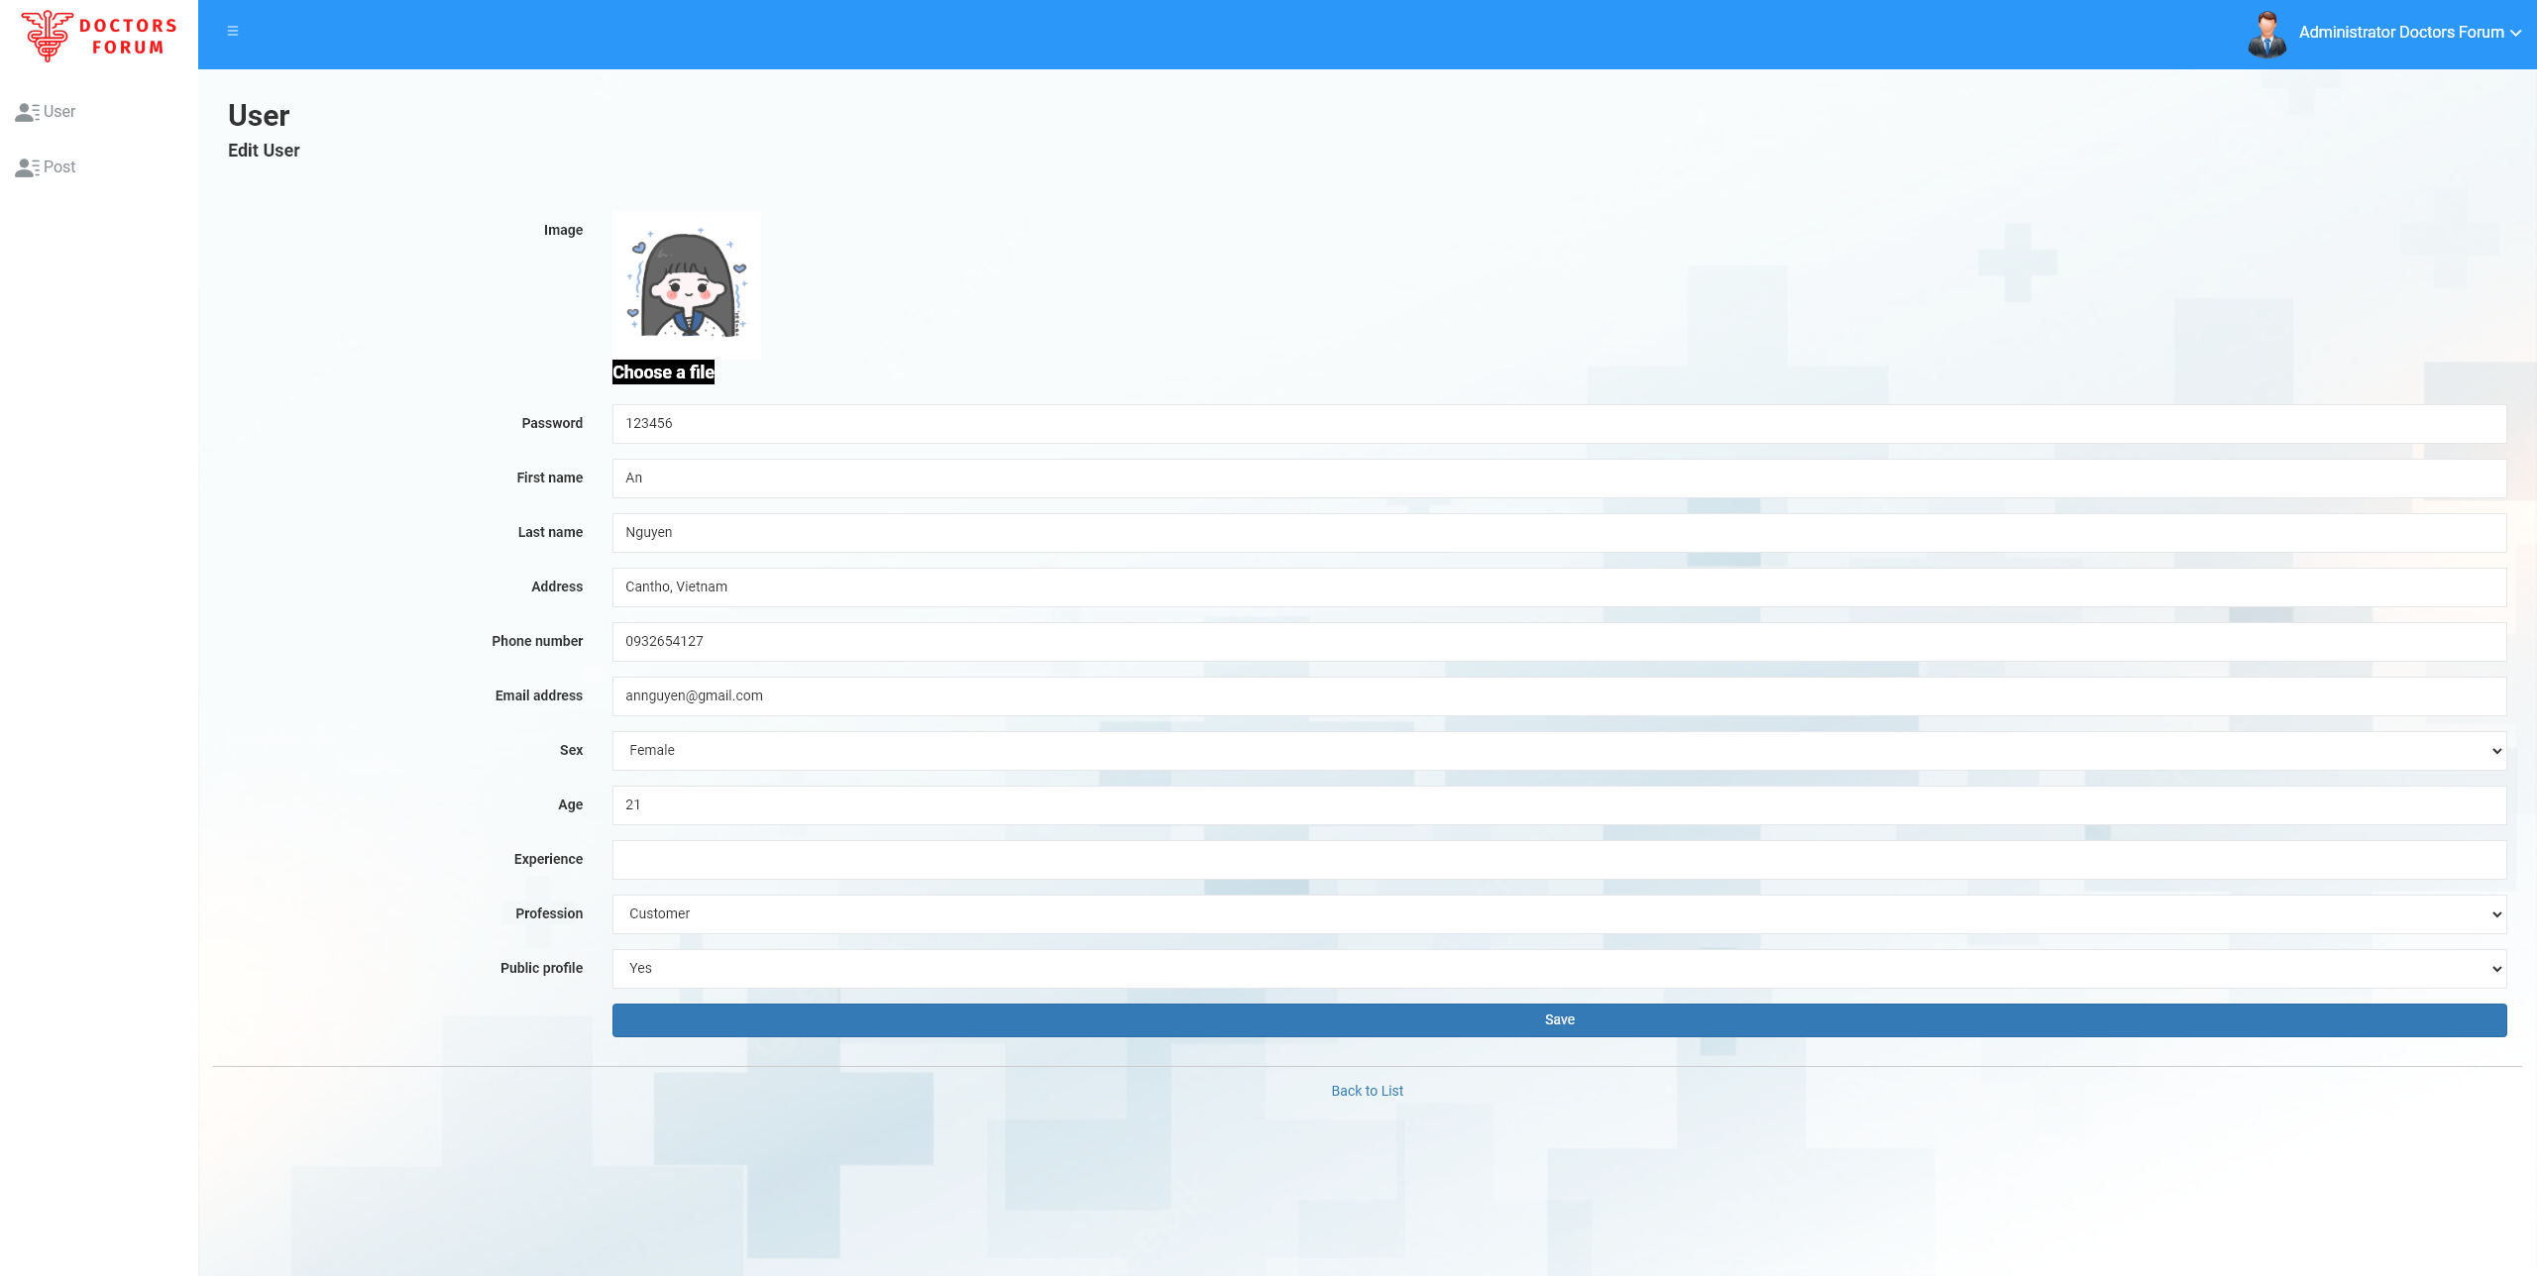

Figure Edit user

* 1. Delete user

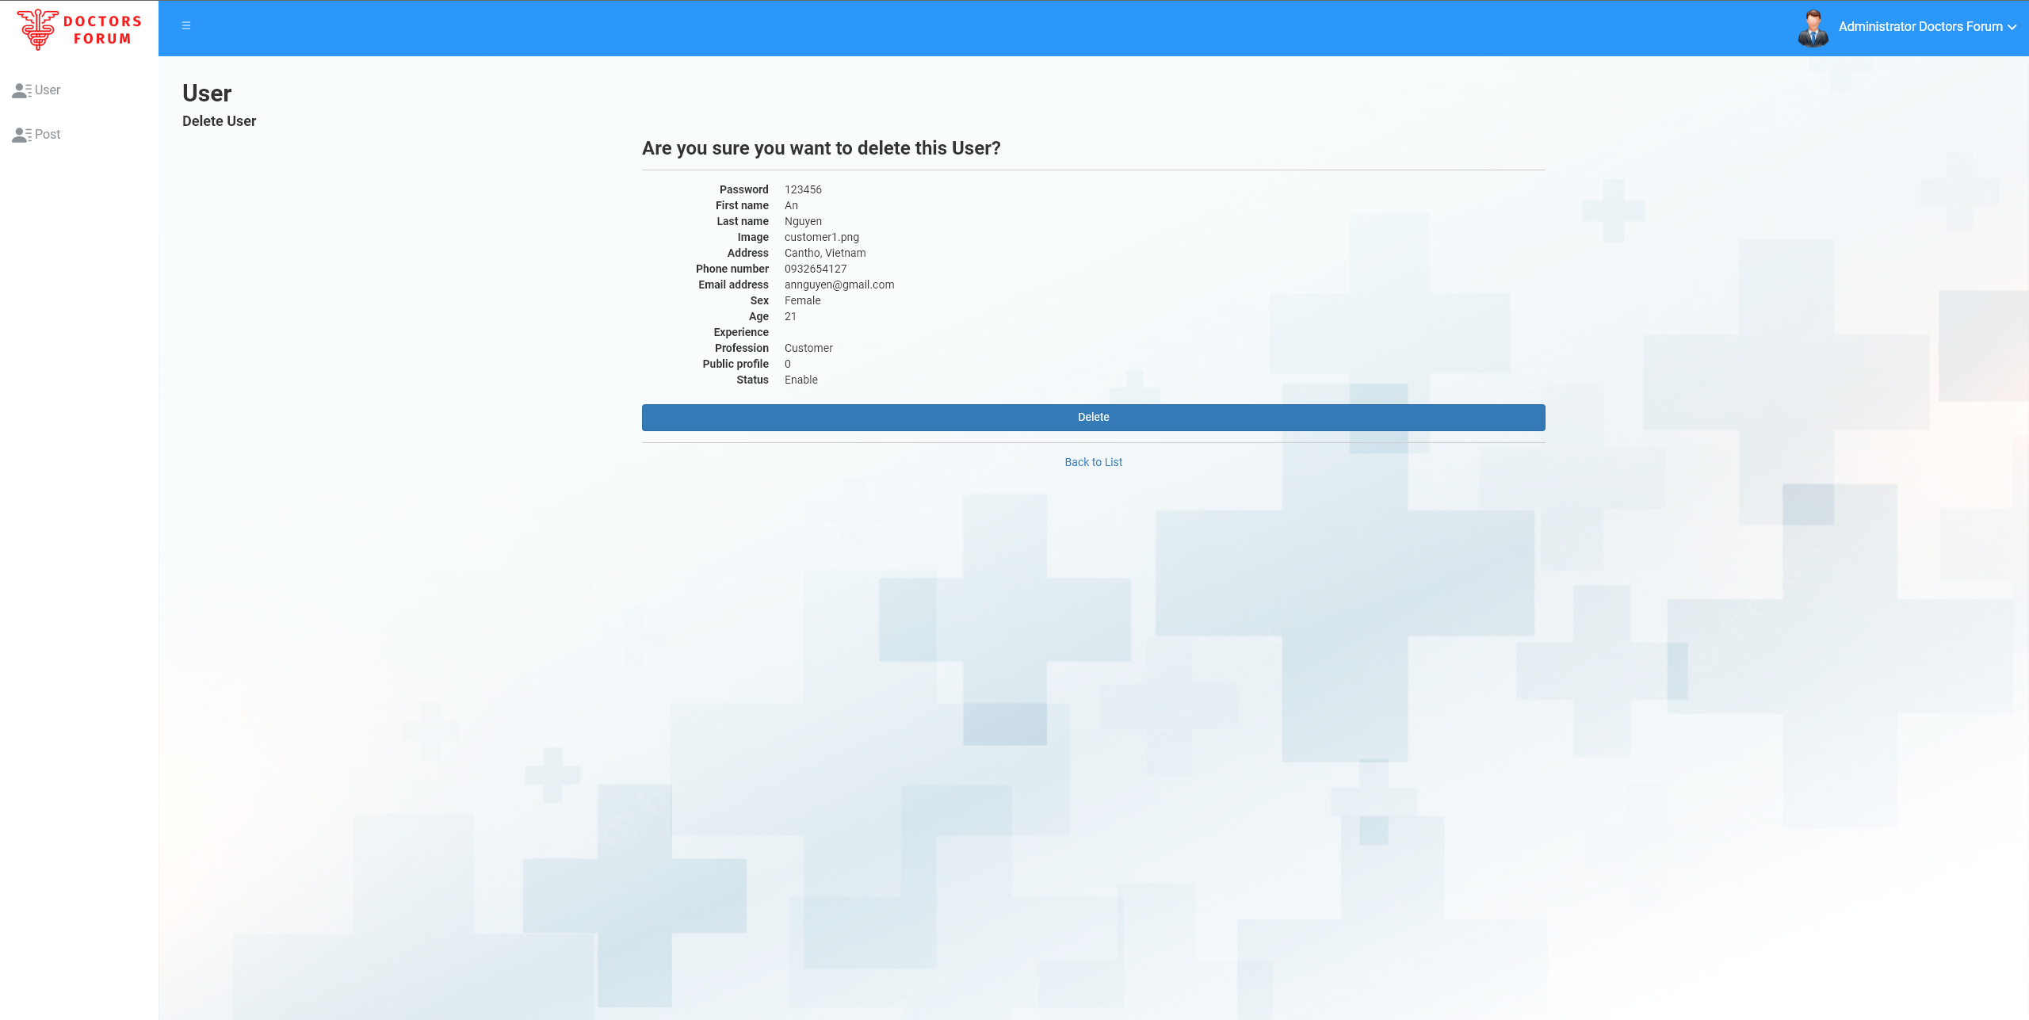

Figure Delete user

* 1. Post management

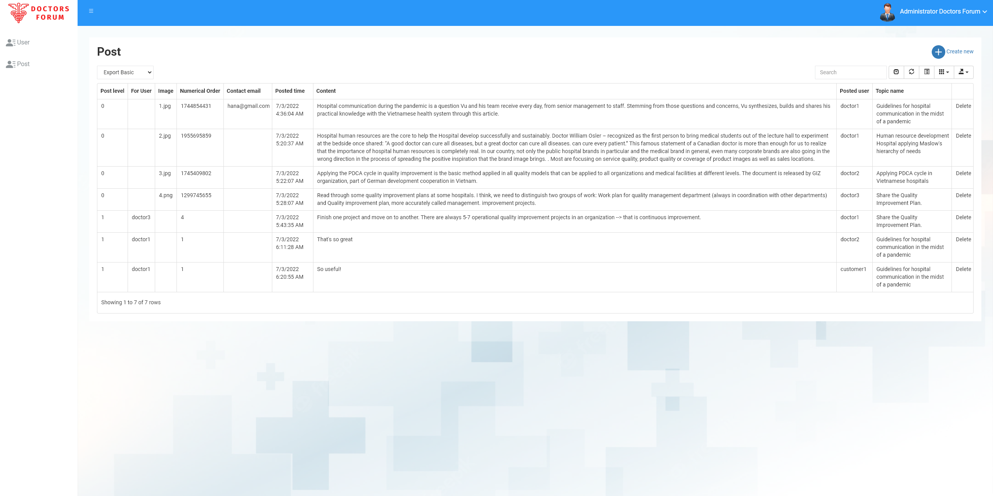

Figure Post management

* 1. Create Post

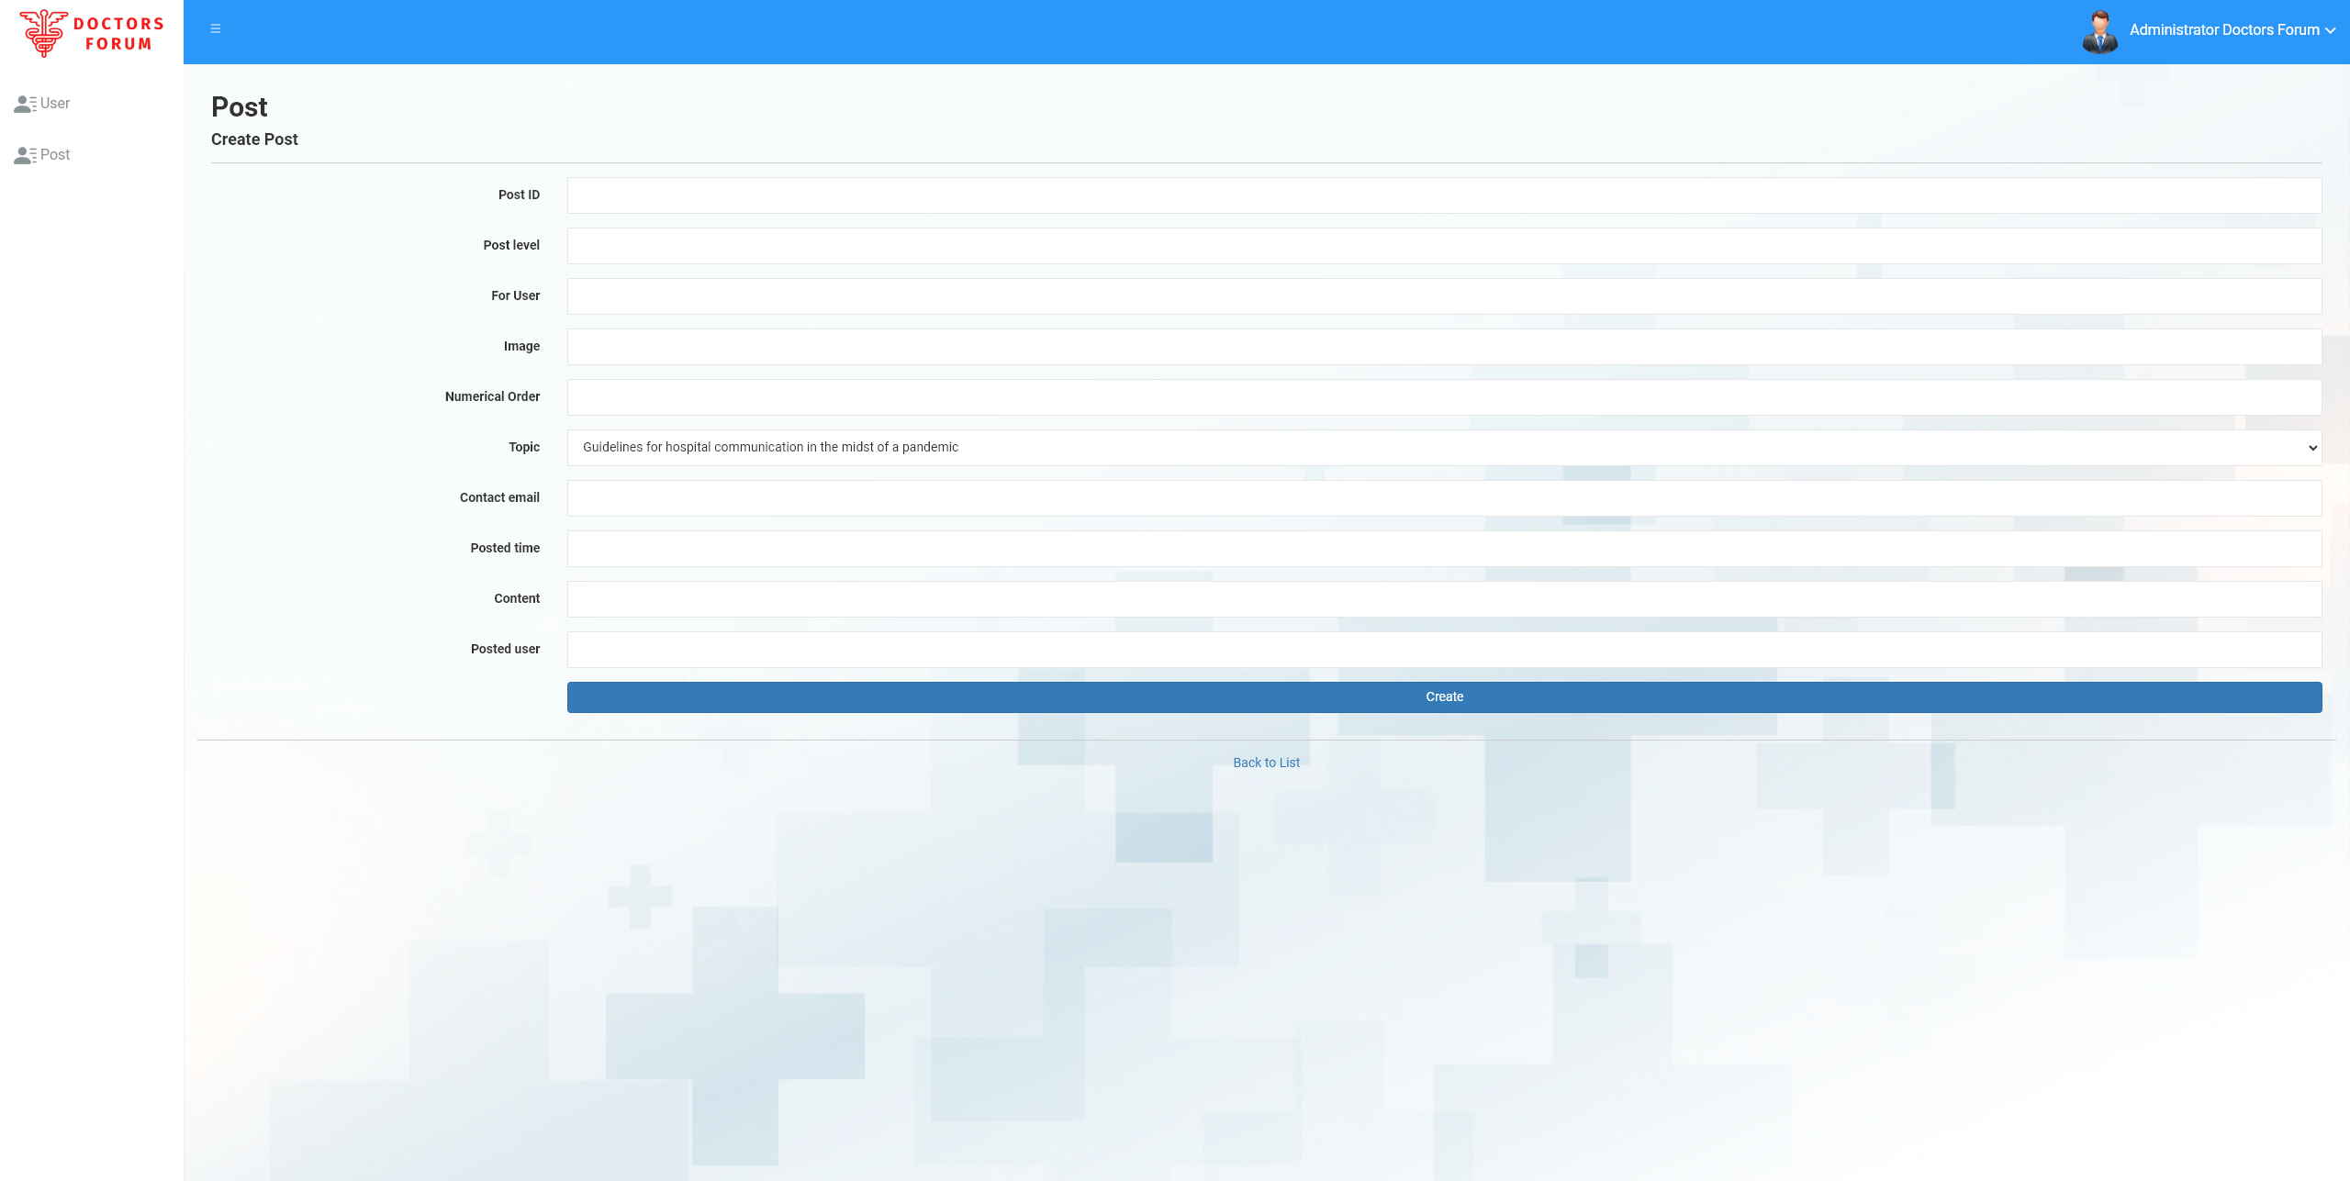

Figure Create Post

* 1. Delete Post

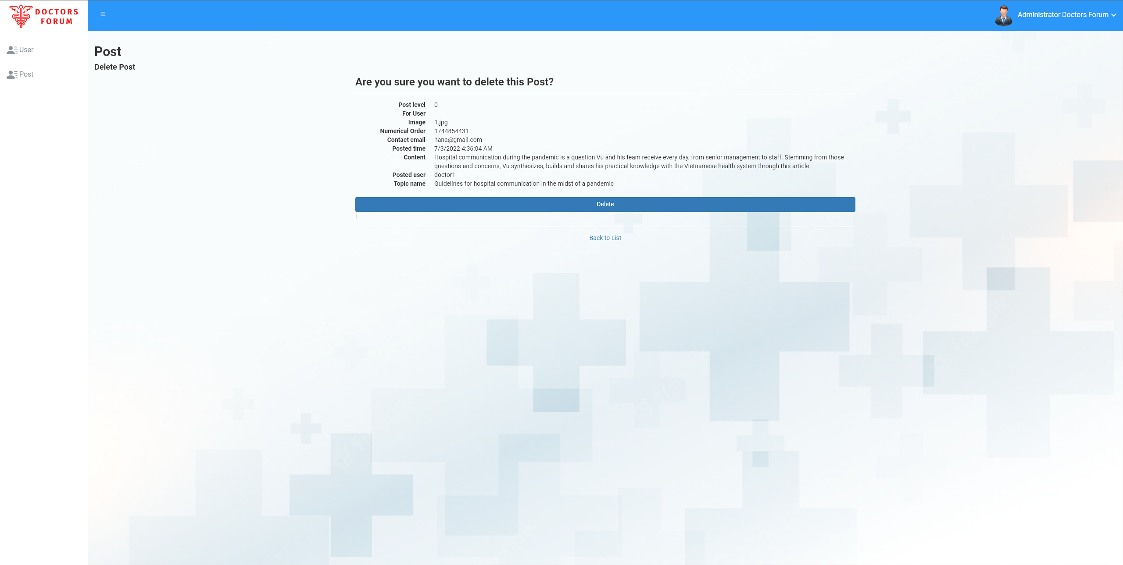

Figure Delete Post

* 1. View and edit profile

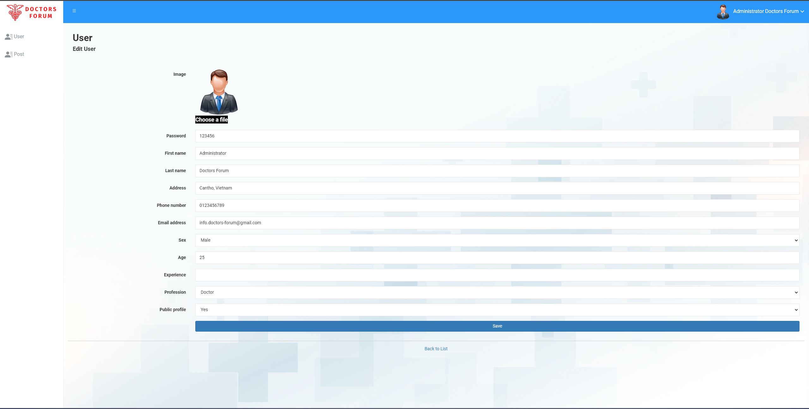

Figure View and edit profile

* 1. Logout

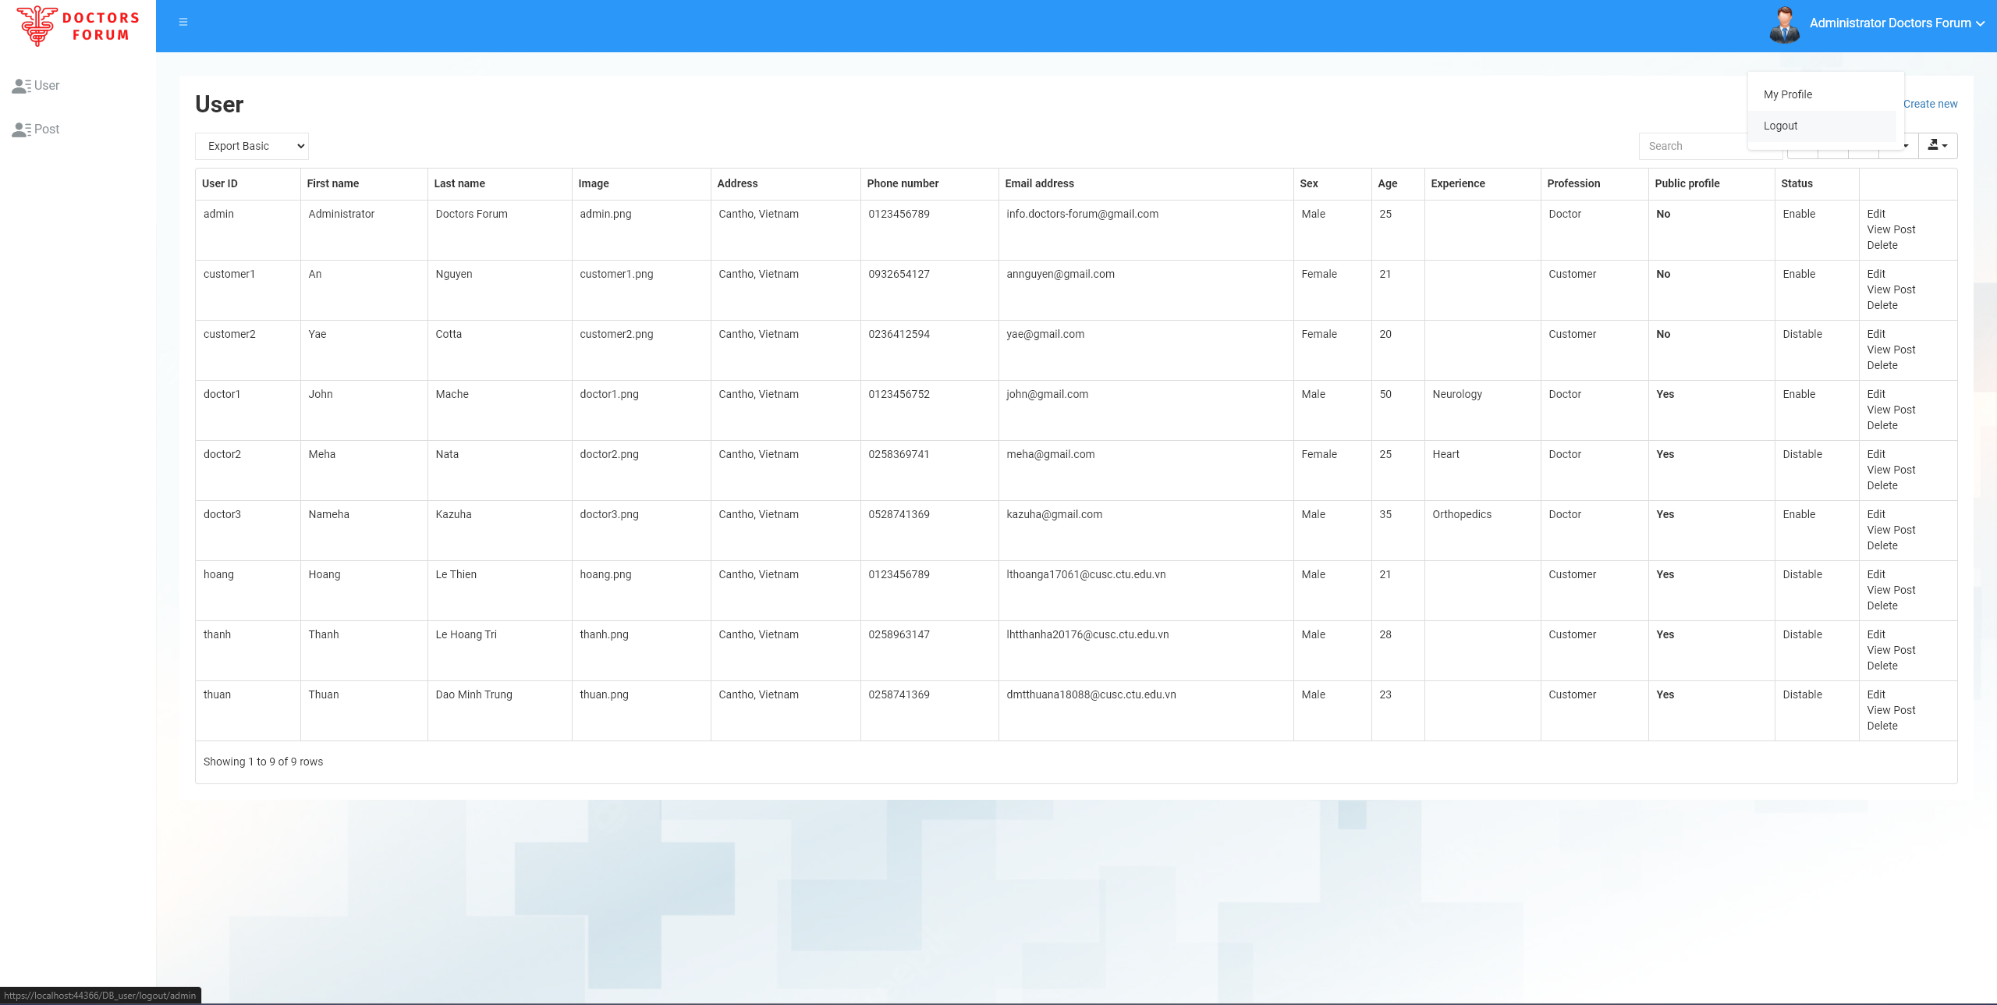

Figure Logout

1. Client Page
   1. Home Page



Figure Home page

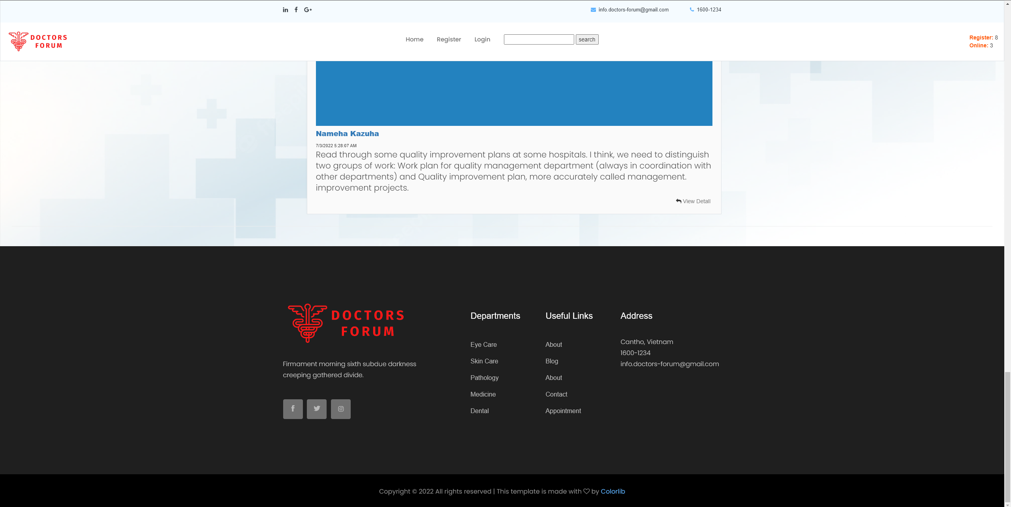

Figure End of home page

* 1. View post

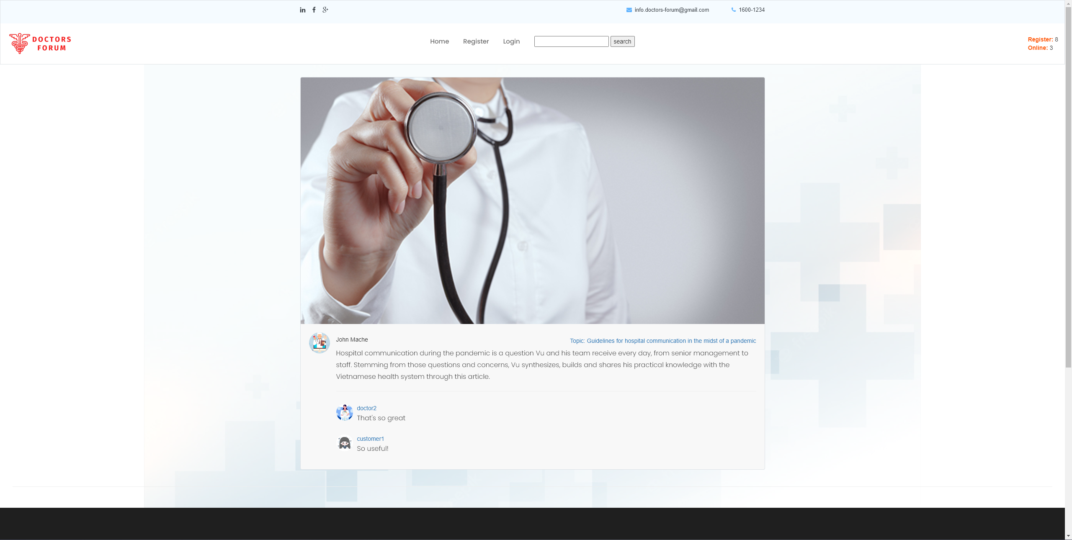

Figure View post

* 1. Register User

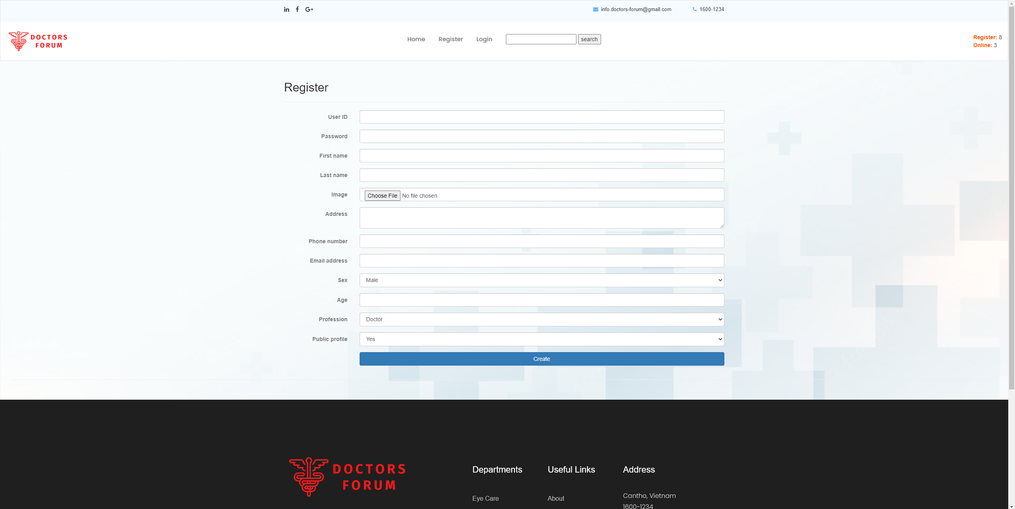

Figure Register User

* 1. Login

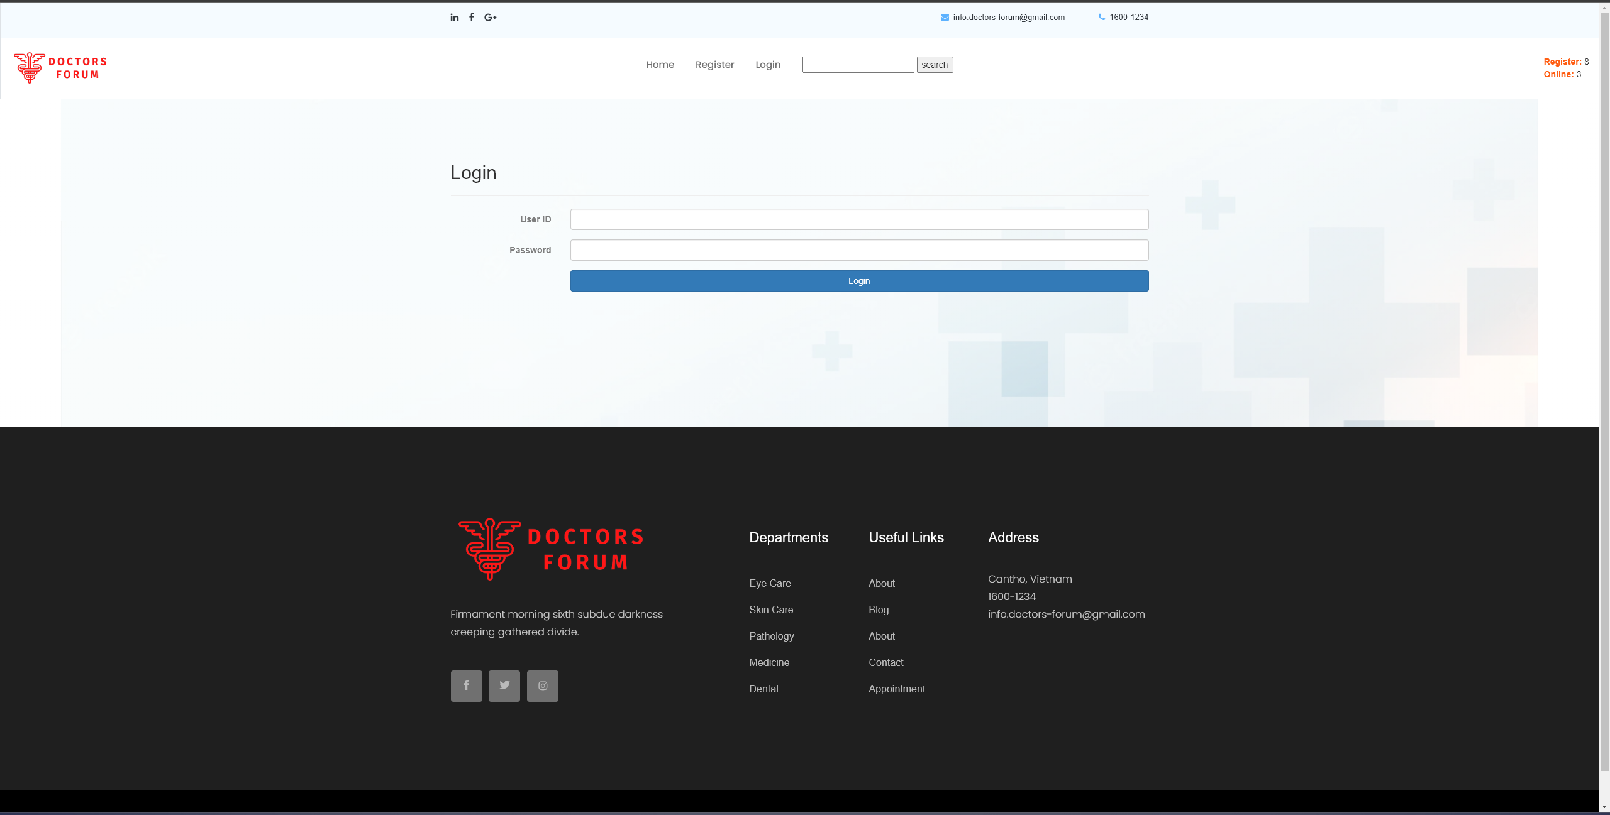

Figure Login

* 1. Customer profile

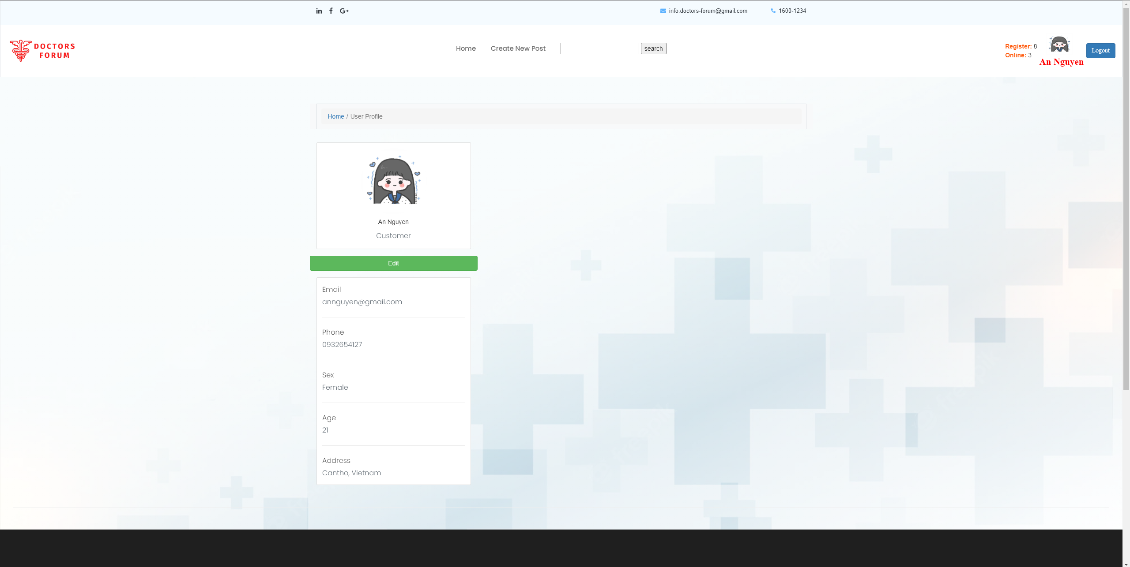

Figure Customer profile

* 1. Edit profile customer

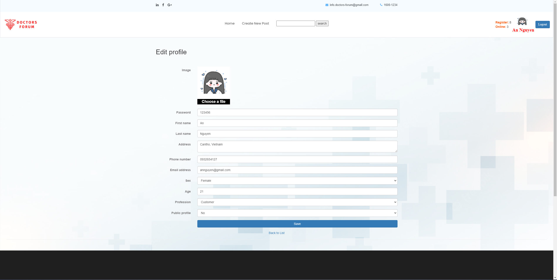

Figure Edit profile customer

* 1. Doctor profile

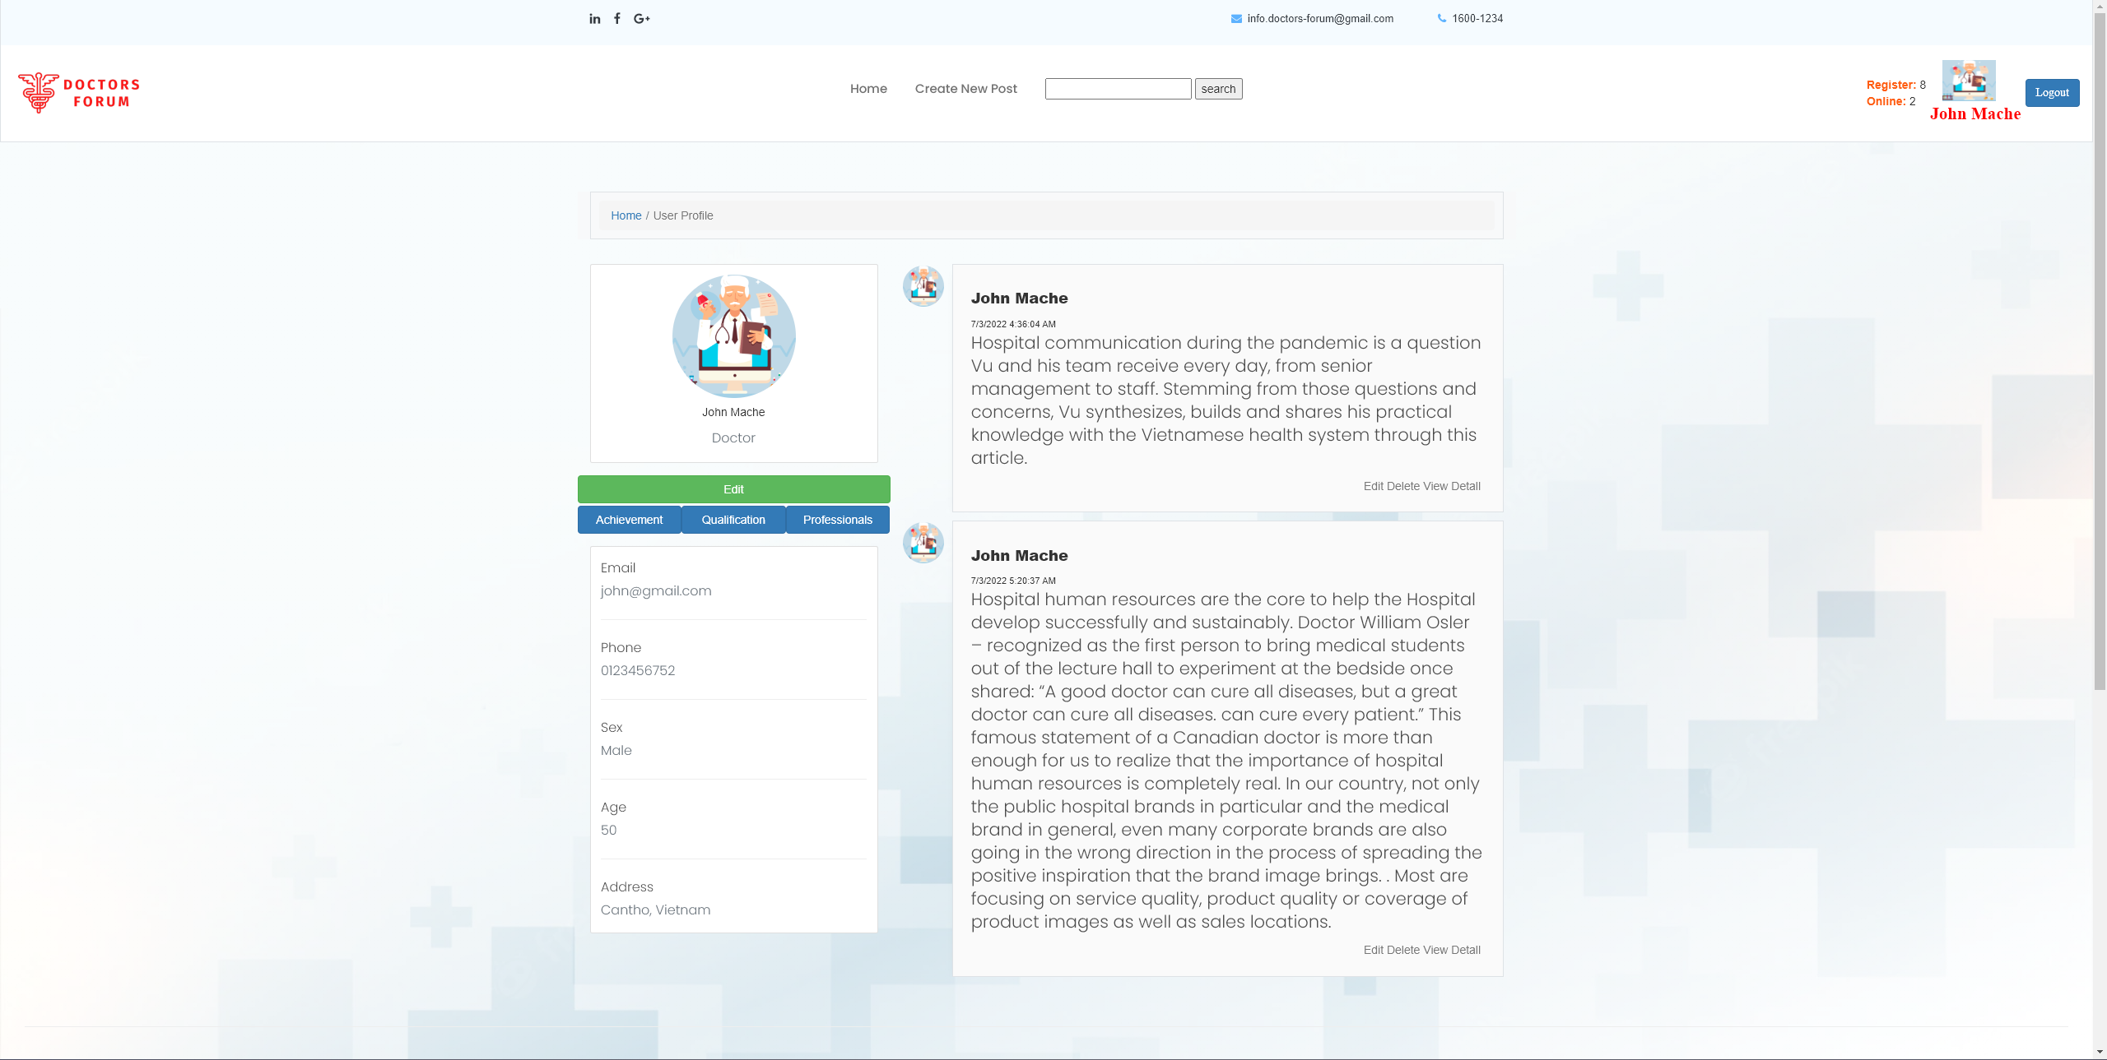

Figure Doctor profile

* 1. Edit doctor profile

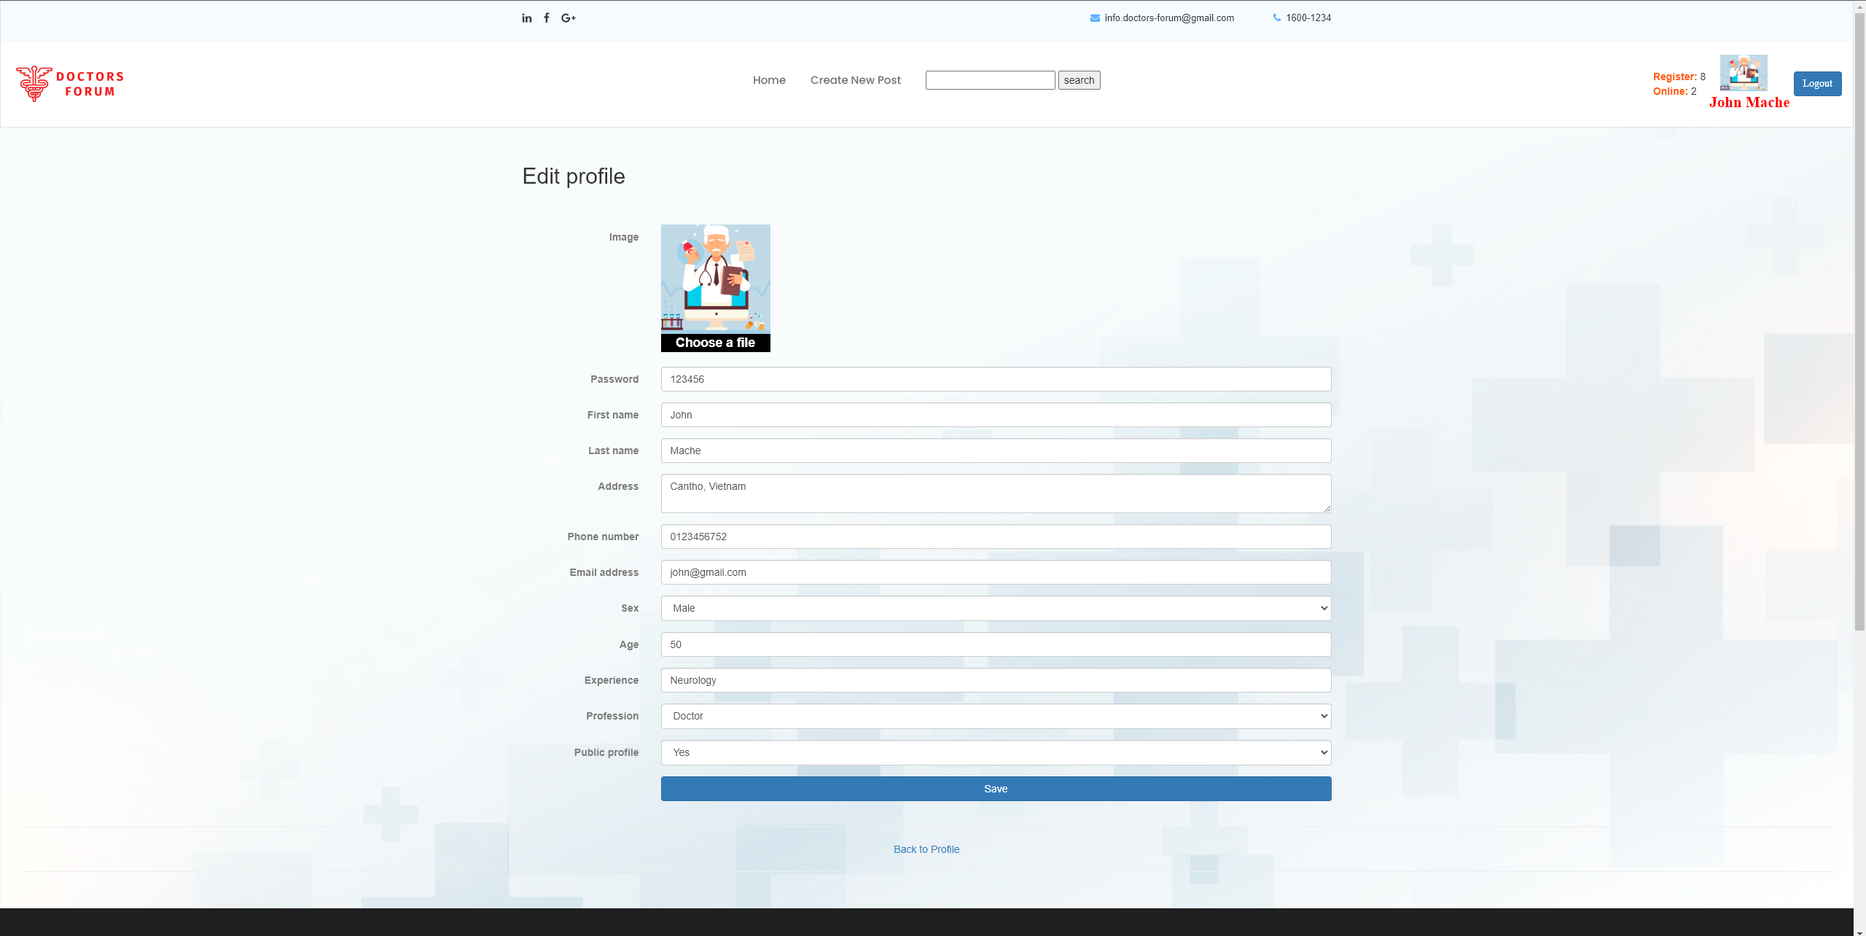

Figure Edit doctor profile

* 1. Doctor Achievement:

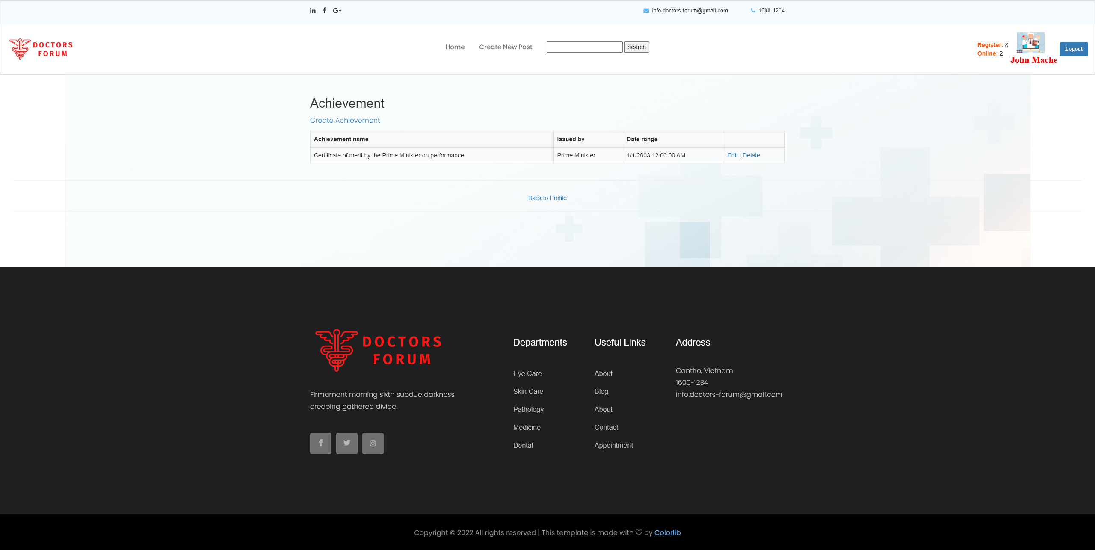

Figure Doctor Achievement

* 1. Create Achievement:

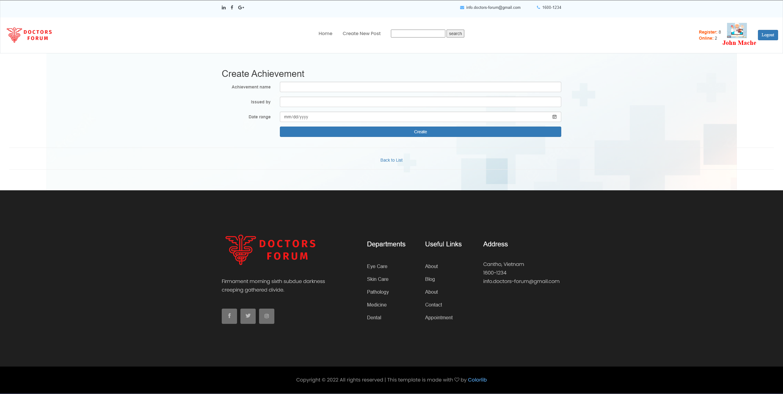

Figure Create Achievement

* 1. Edit Achievement:

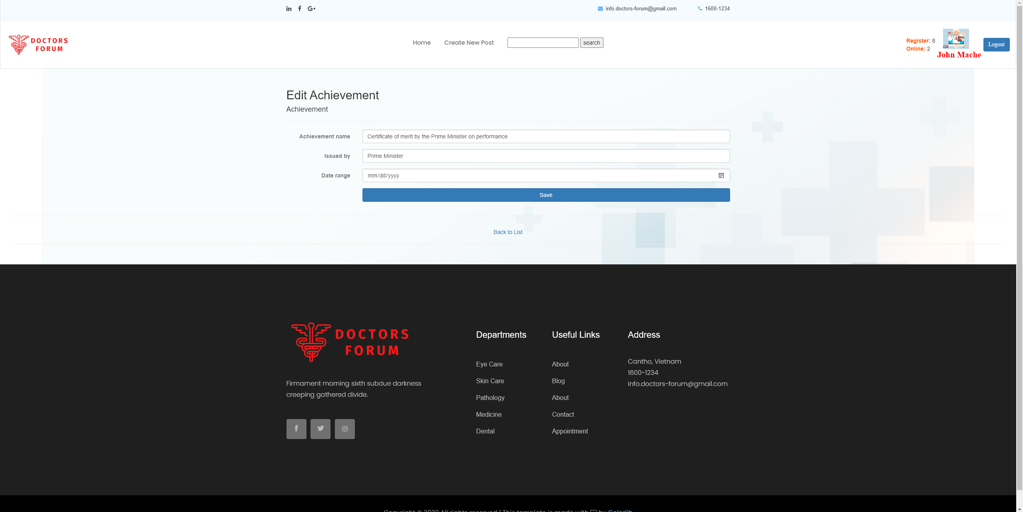

Figure Edit Achievement

* 1. Delete Achievement:

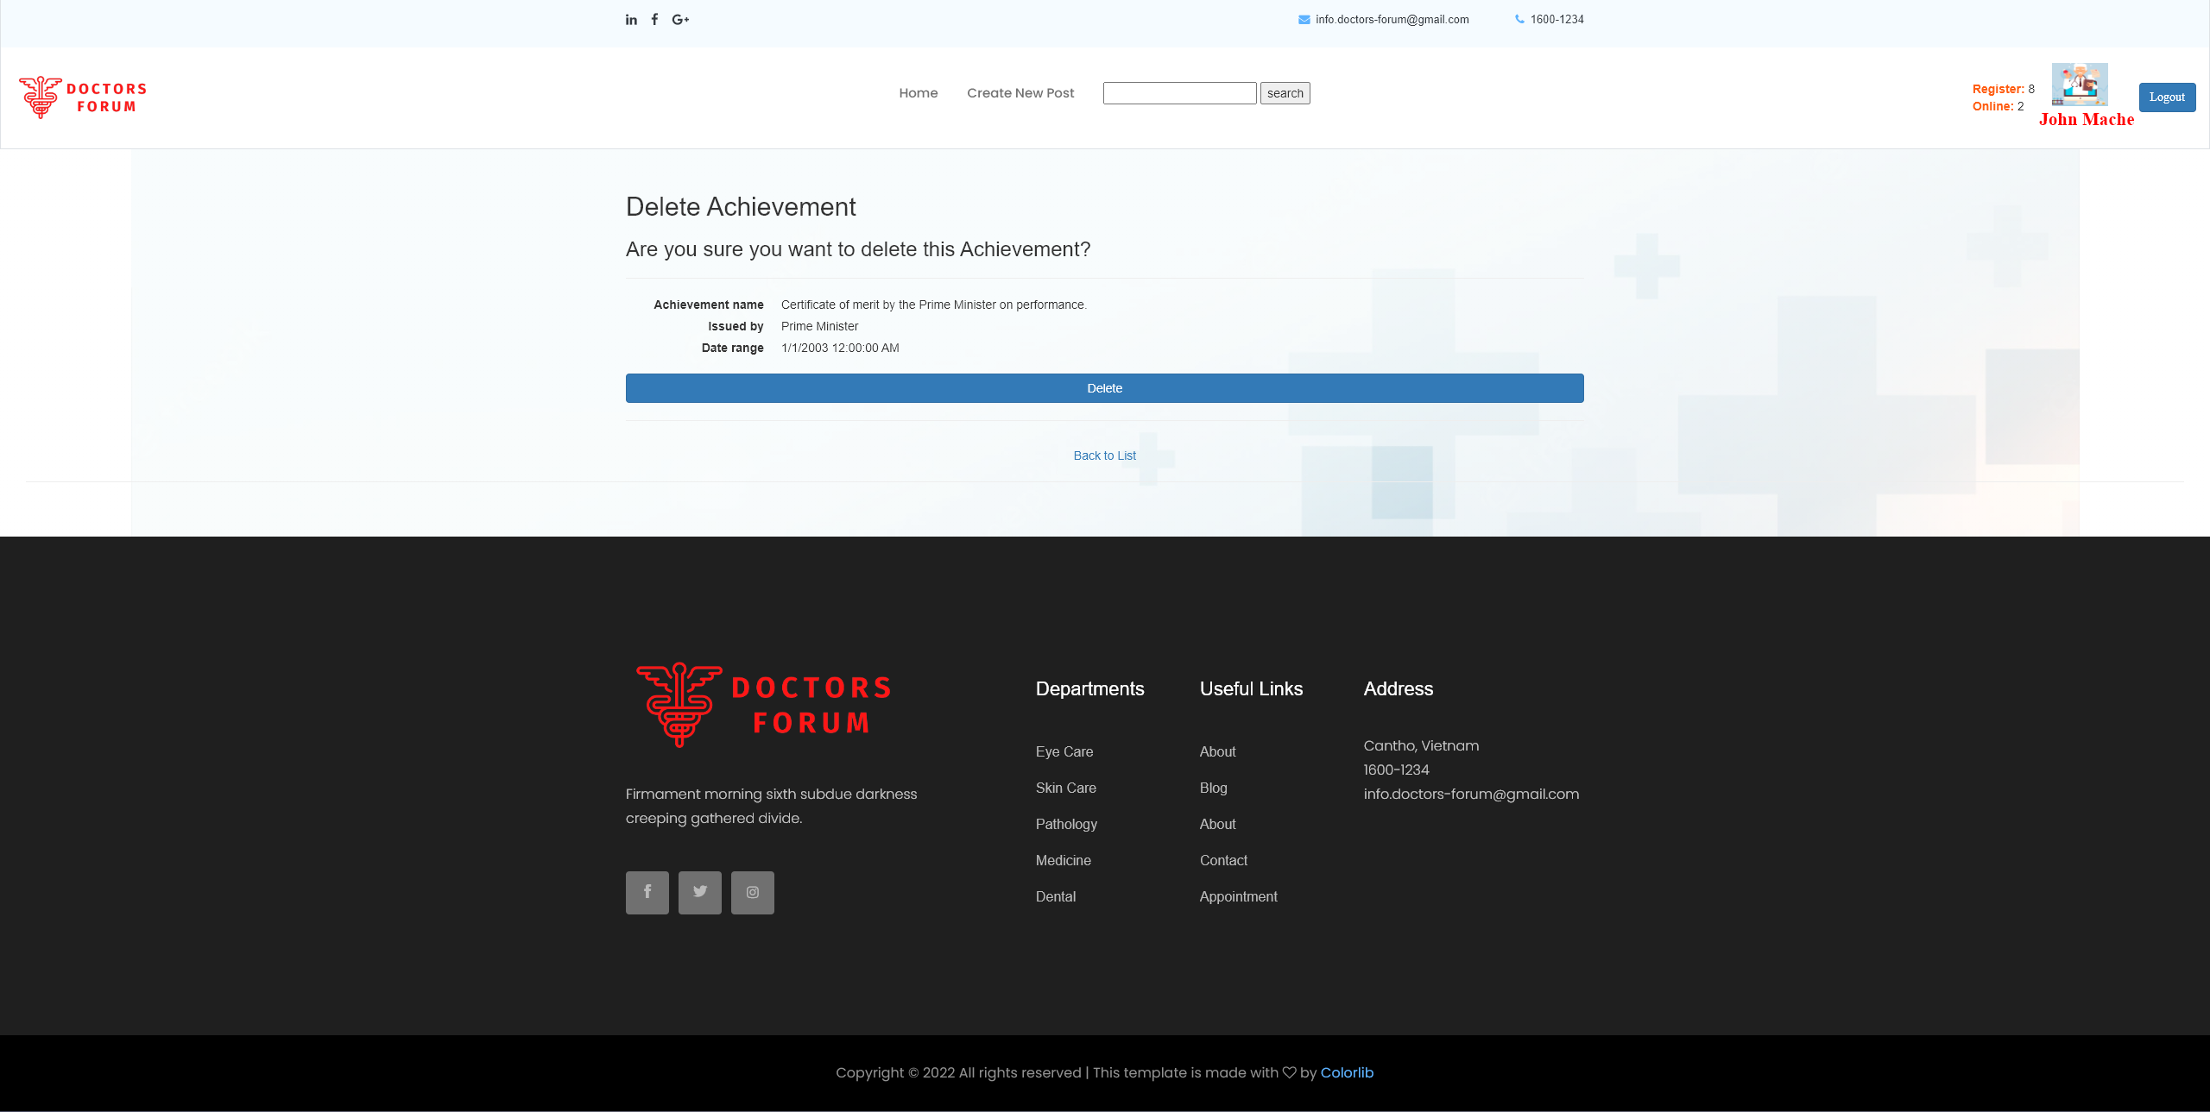

Figure Delete Achievement

* 1. Doctor Qualification

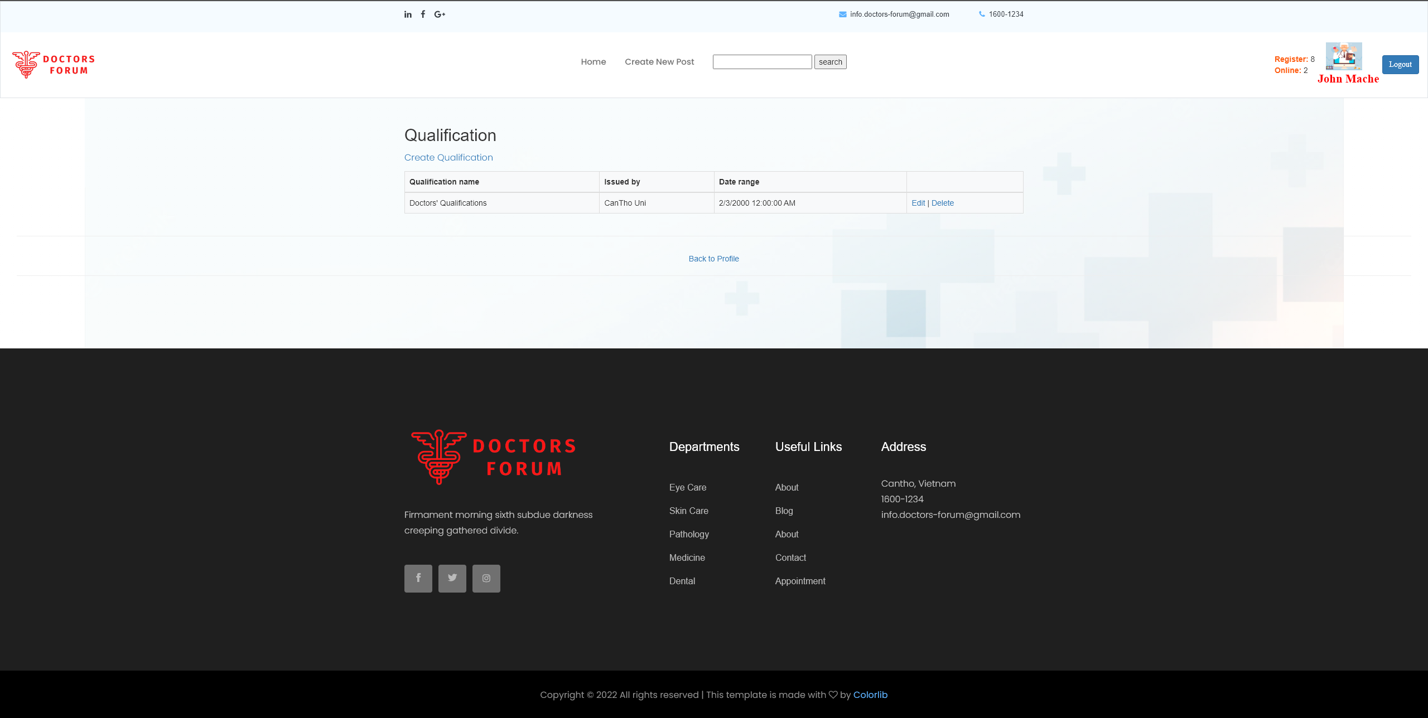

Figure Doctor Qualification

* 1. Edit Qualification:

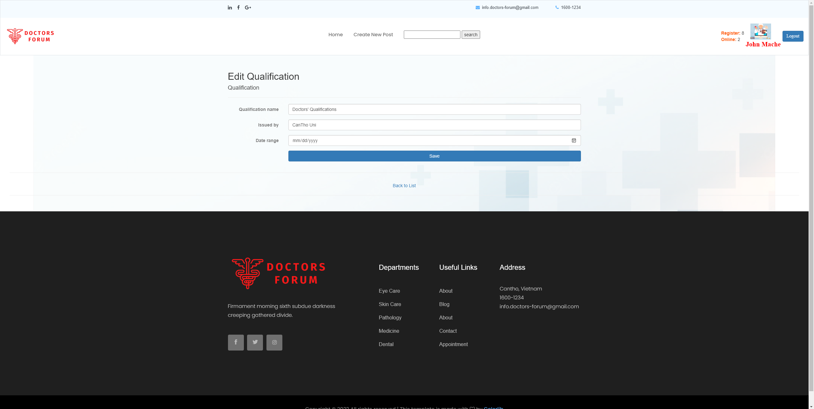

Figure Edit Qualification

* 1. Delete Qualification:

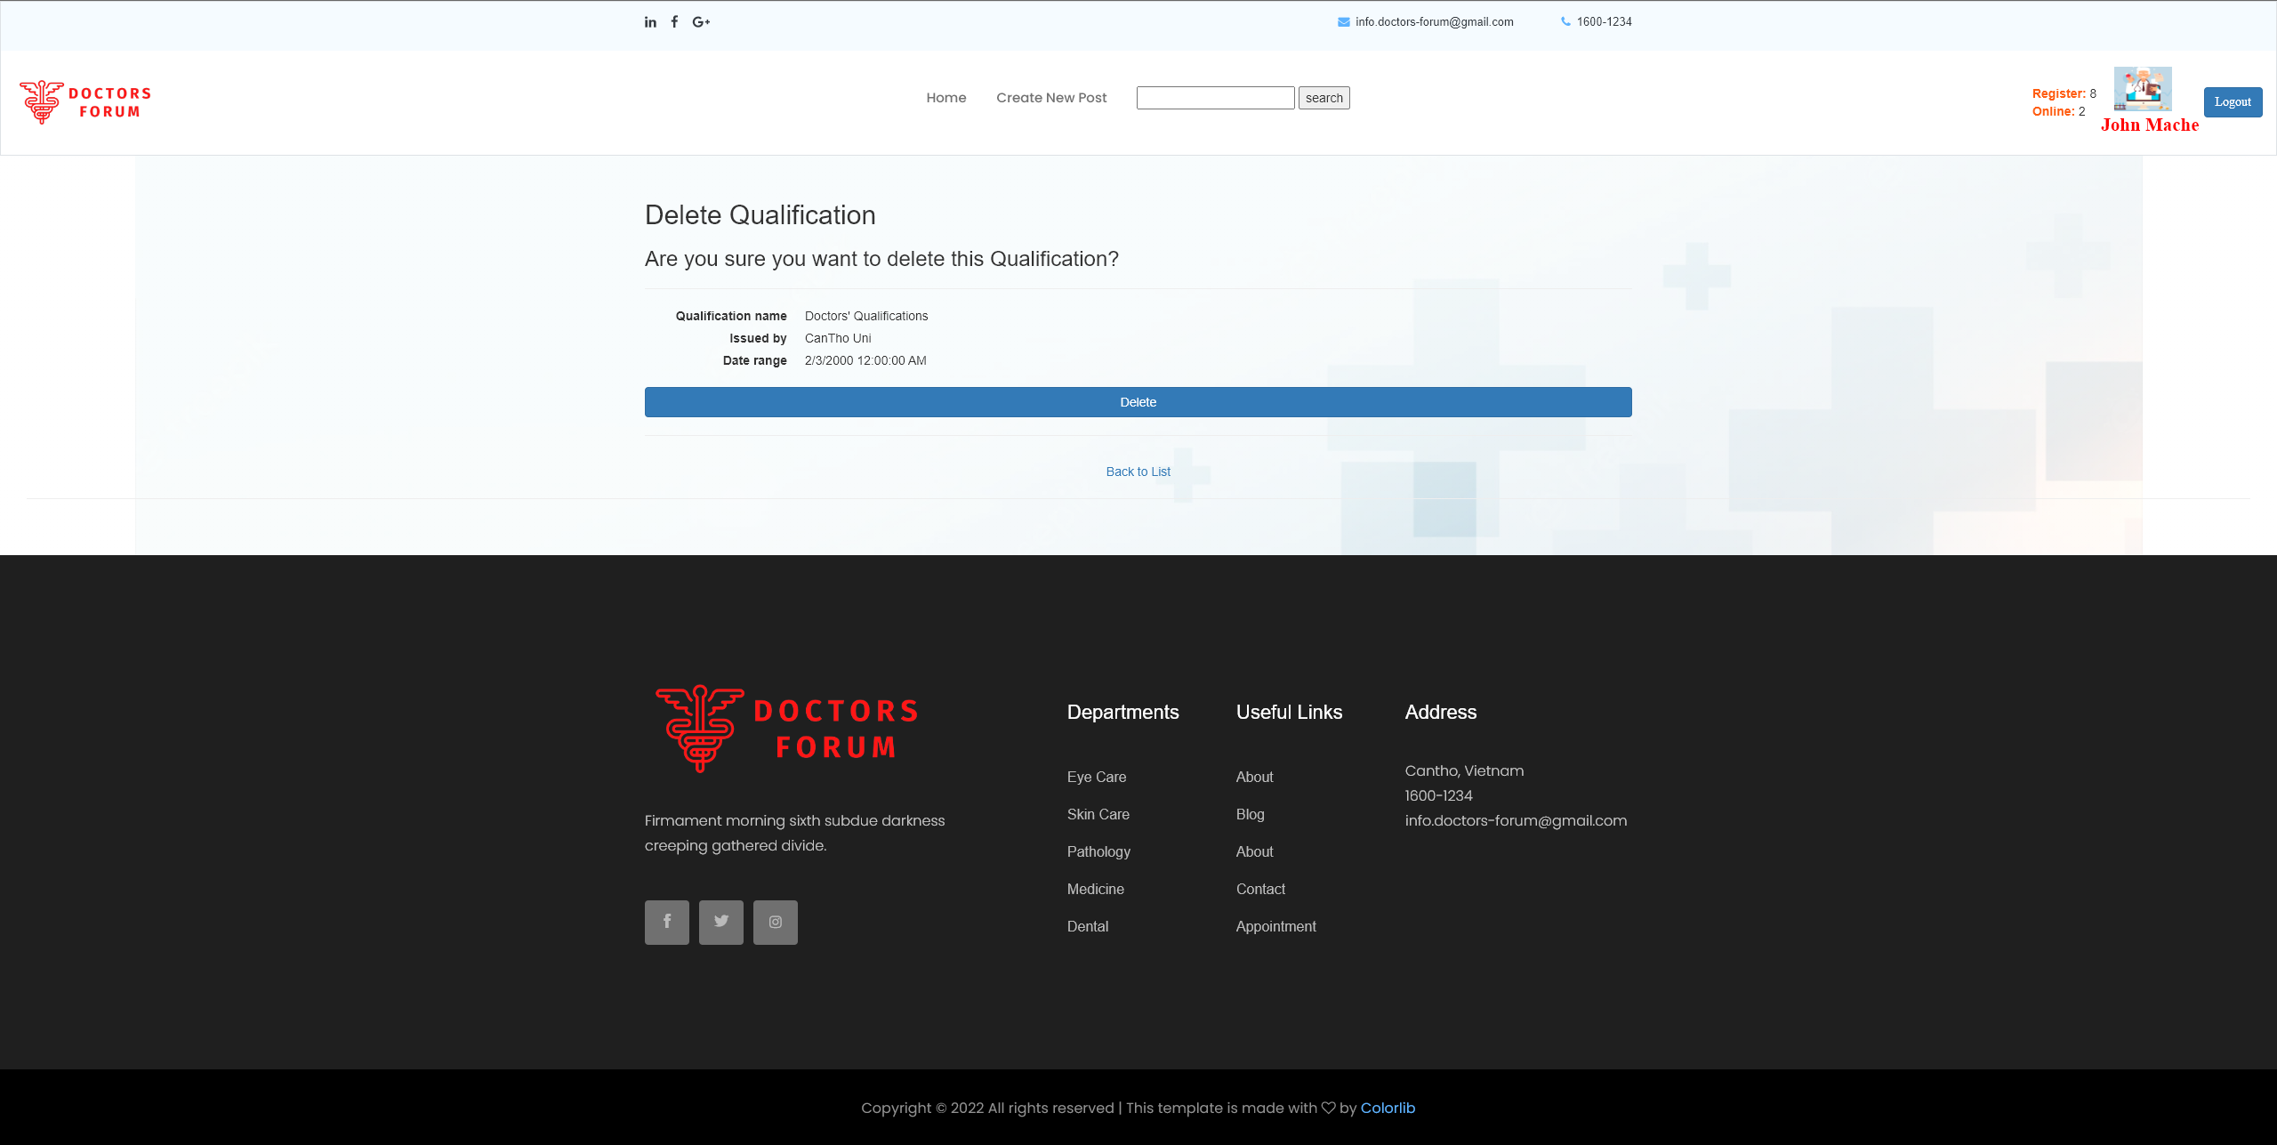

Figure Delete Qualification

* 1. Doctor Professional:

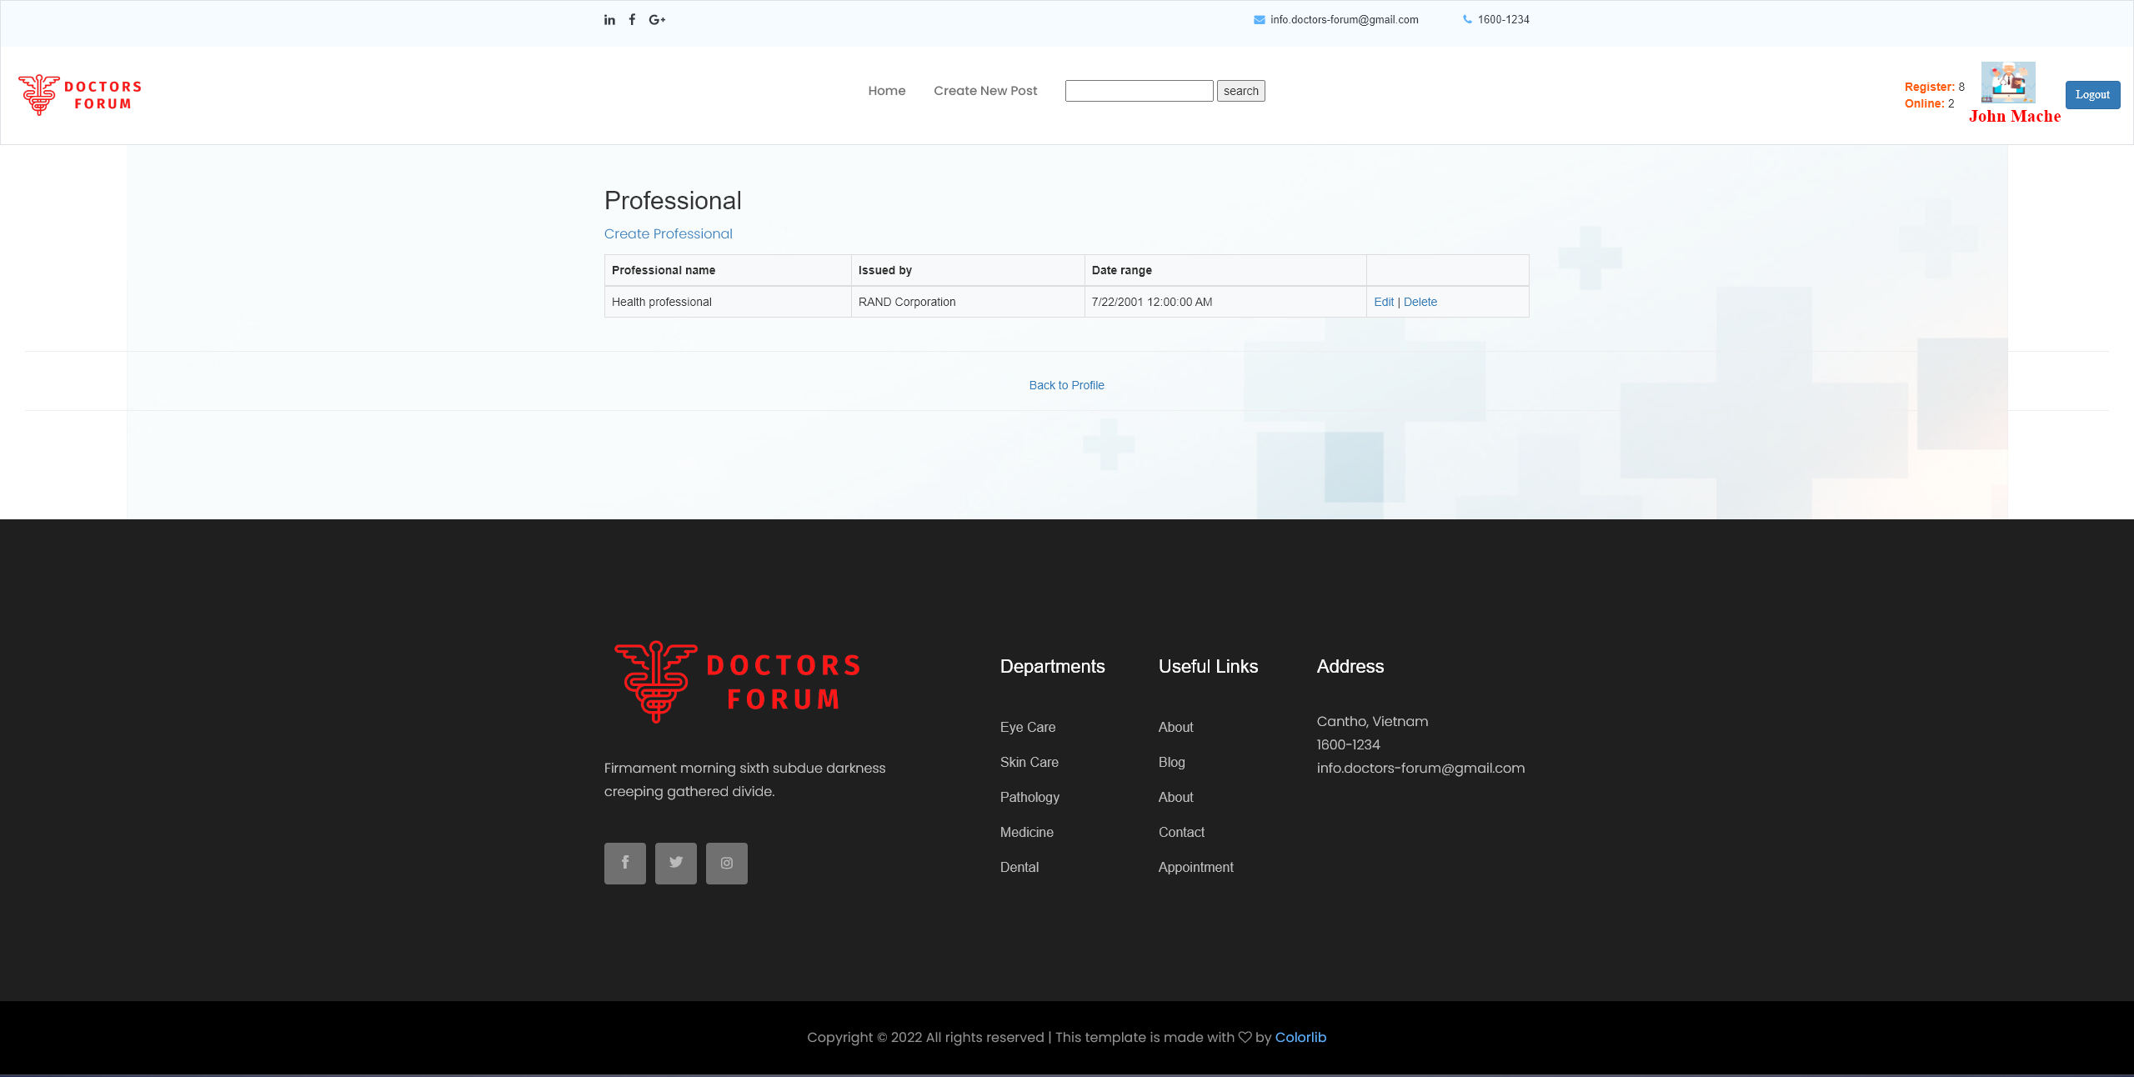

Figure Doctor Professional

* 1. Create Professional:

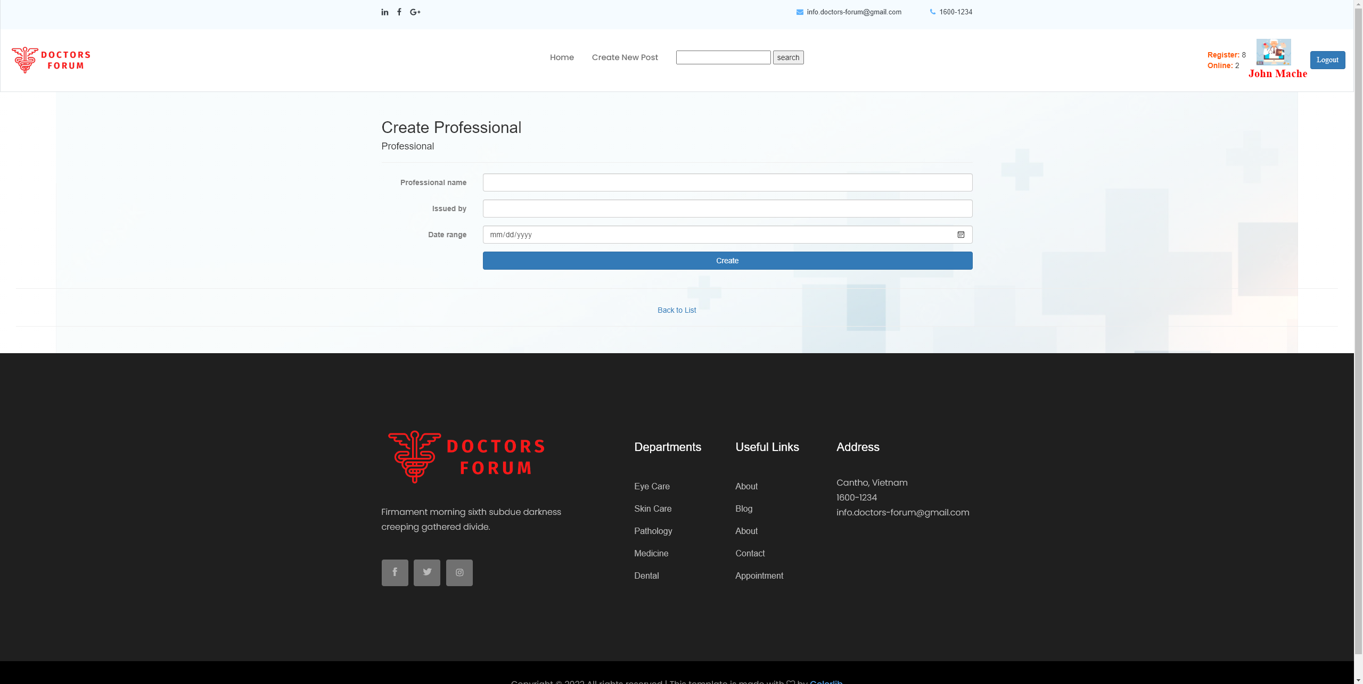

Figure Create Professional

* 1. Edit Professional:

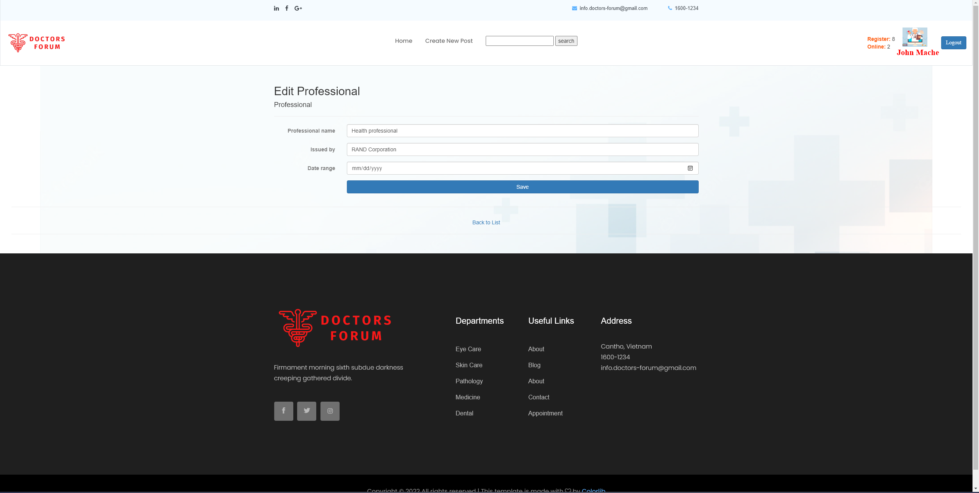

Figure Edit Professional

* 1. Delete Professional:

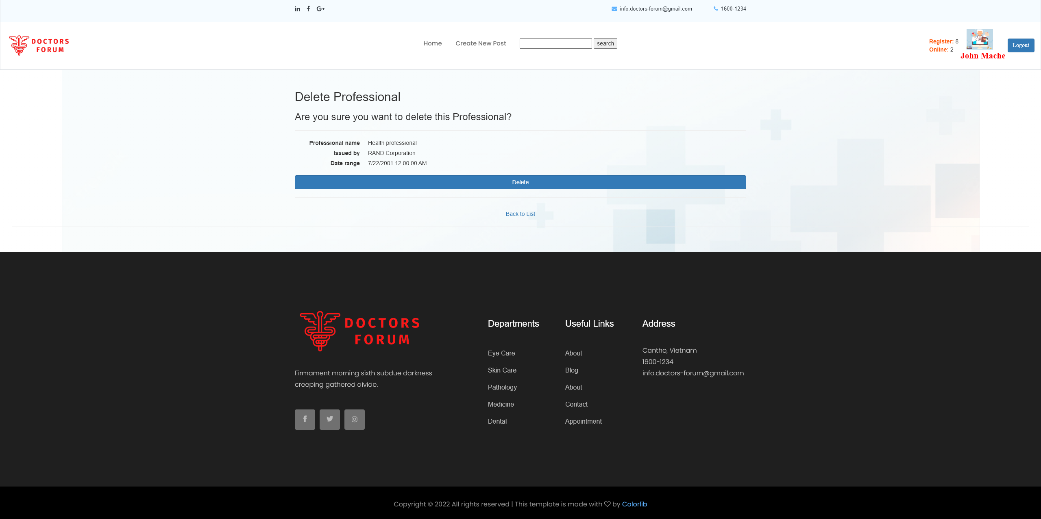

Figure Delete Professional

* 1. Create new post

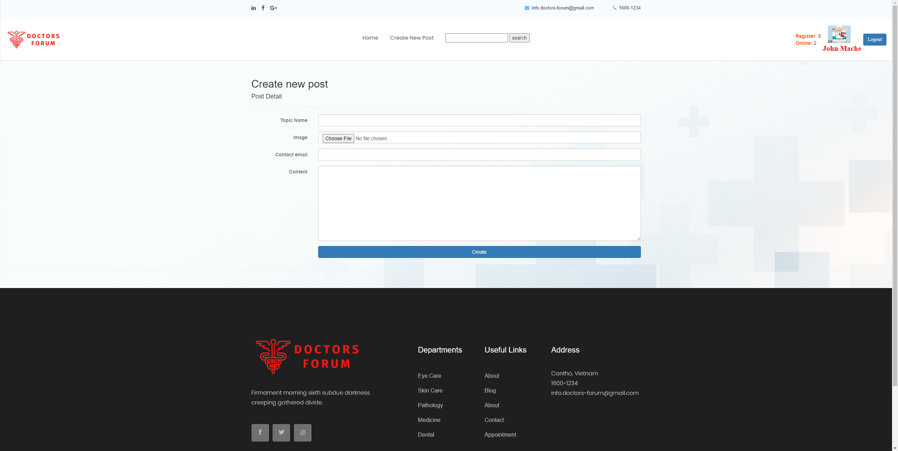

Figure Create new post

* 1. Comment on Post

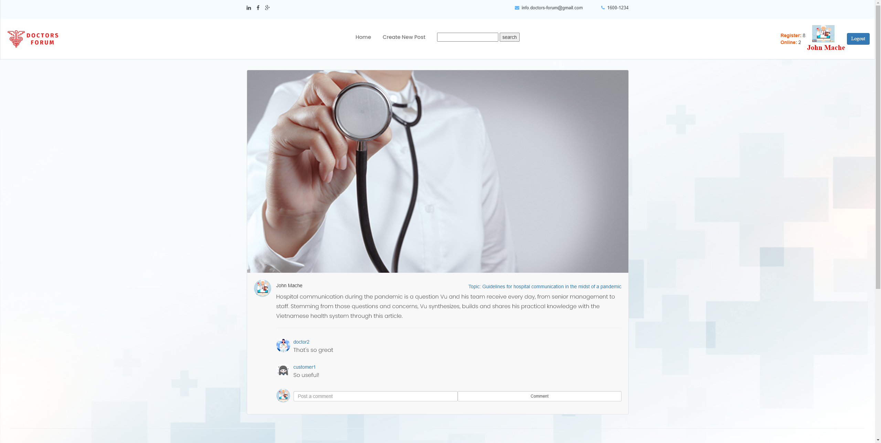

Figure Comment on Post

* 1. Search:

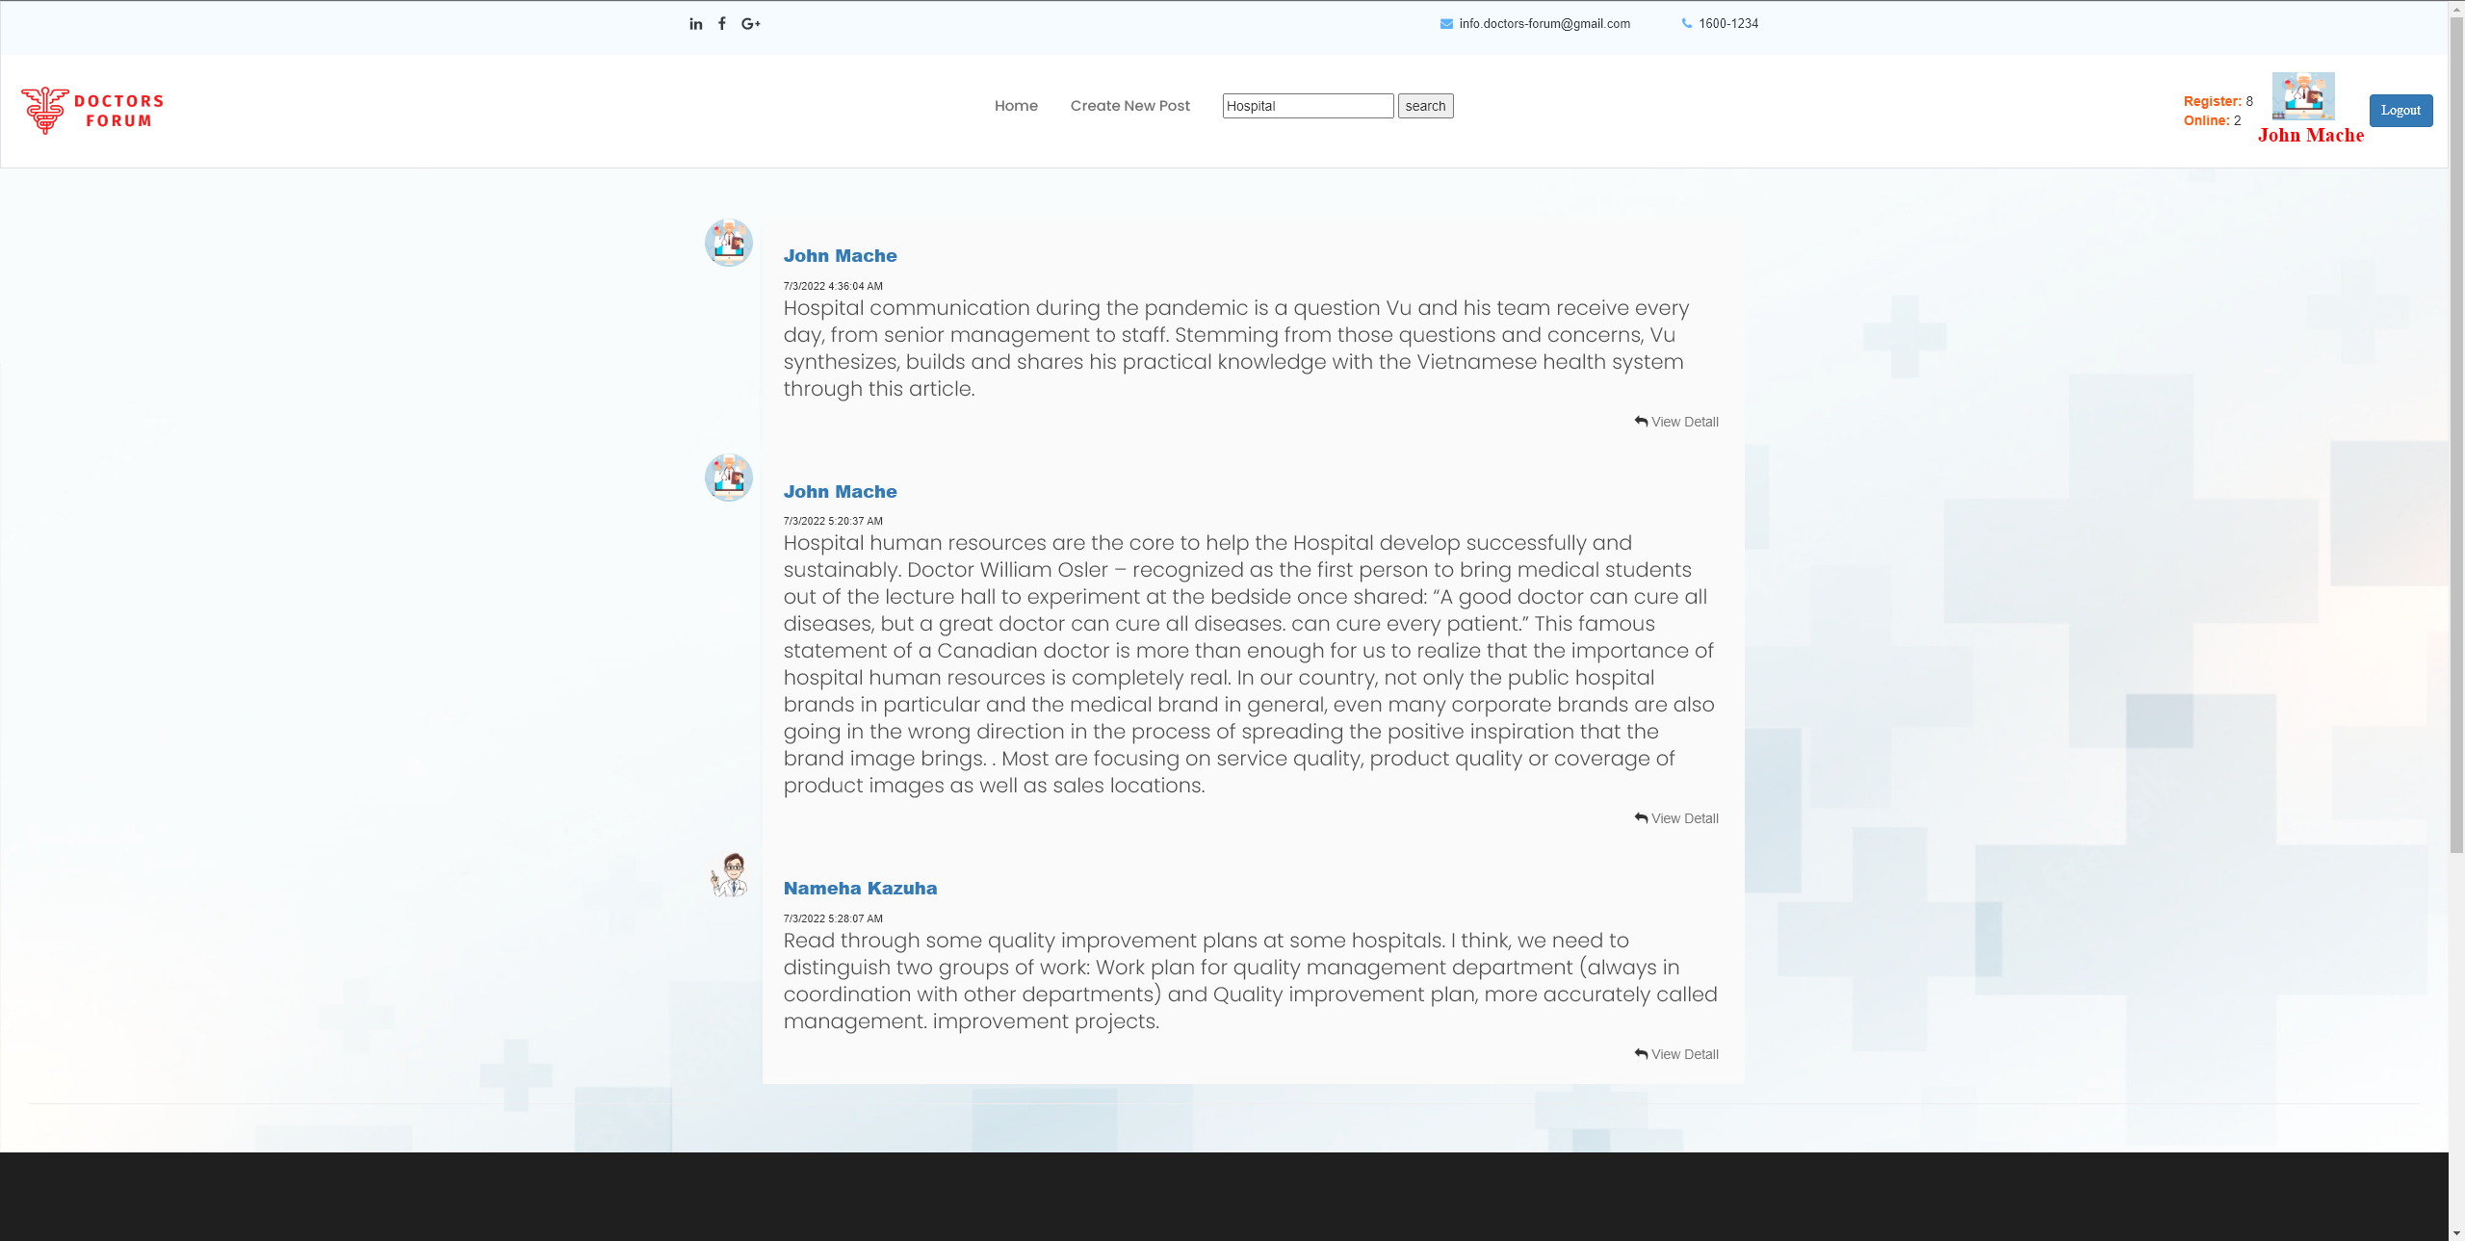

Figure Search